
USER INTERFACE DESIGN
23CSE113
LAB MANUAL
SUBMITTED BY
NAME | K.GAYATHRI
ROLL NO | AV.SC.U4CSE25120
YEAR/SEM/SECTION | 1ST YEAR/SEM-2/CSE-B
CREDITS | 03

SUBMITTED TO | DR. RAJ KUMAR BATCHU
DESIGNATION | ASST.PROFFESSOR(SL Grade)
DEPARTMENT | SCHOOL OF COMPUTING
INDEX
 | TITLE | PAGE NO | REMARKS
1. | WEEK 1 : 1. Installation of VS CODE tool  2. Understanding basic of html structure  3. Understanding basic html tags | 3-10
2. | WEEK 2 : 1. To design a simple web page using HTML that demonstrates the use of background color, background image, heading styling, and preformatted text  2.To create a static webpage using only HTML that displays basic information about Amrita Vishwa Vidyapeetham, including a heading, descriptive text, background styling through HTML attributes, and a table showing the list of campuses in different states.  3.To design a restaurants menu webpage using HTML and displaying menu items in a table format with proper layout and visual styling.
3. | WEEK 3 : 1. Construction of Class Timetable using html Elements  2 . Construction of web page Displaying Each Syllabus of each Subject Displaying as Image Format and also displaying the Corresponding time table of current semester
4. | Week 4: 1 . a college wants to collect student details through an online admission form design a registration form using only html tags(no css) with propern labels table alignment,background color and borders  2 . A Company wants to design a webpage that display two different forms side by side using iframes in which one should display a login form and other should display register form
5 | Week 5: 1.To create a responsive card layout using HTML and CSS with three cards, each containing an image, title, and button  2. To design a mini website using iframe with navigation links (Home, About, Contact), where clicking on each link displays the respective content within the same page using internal or external CSS.  3. To design an Amrita login page using HTML and CSS that displays different campuses, where clicking on each campus shows its details on the same page
6. | WEEK 6: 1. Design a responsive e-commerce application using the grid layout. This application should contain different categories of products such as electronics, clothing, home-appliances, books Based on the category we select corresponding products should be displayed on the sidebar
7 | WEEK 7 : 1. create a github account and create a repository named UID lab with roll no and upload every week experiments and lab report in repository and make repository file
8 | WEEK 8 : 1.Create a webpage that displays a square that continuously rotates 360° using CSS animation.  2.Create a ball that moves up and down continuously only using CSS animations  3. Create a circle that moves horizontally and rotates at the same time.
WEEK 9 : 1. Create a webpage using iframe to perform operations like checking positive/negative, palindrome, sum of digits, and reverse of a number using HTML pages.

2.Write a JavaScript program to display different patterns by taking number of rows as input and displaying output using proper formatting
10. | WEEK-10 :  (a).Write a Javascript conditional statement to find design of the product of three numbers using functions.Dispaly an alert box with specified sign.  10(B). Write a Javascript conditional statement to sort three numbers using functions. Display an alert box to show the result.  10(C). Write a Javascript conditional statement to find the largest of five numbers using function and onclick event.Display an alert box to show the result.  10(D): Write a Javascript for loop that will iterate from 0 to 15 . For each iteration, it will check if the current number is odd or even and display a message to the screen.  10(E). Write a Javascript program to read 6 subjects marks from the student then compute the average marks of the student. Then this average is used to determine corresponding grade.
11. | WEEK 11 :  11(A). A website requires users to enter a username. The system should display a message while typing if the username is less than 5 characters.  11(B). A registration form should validate email format before submission. If invalid, the form should not be submitted.  11(C). A system should check password strength while typing and display whether it is weak or strong.  11(D). A form should validate a mobile number when the user leaves the input field. The number must be exactly 10 digits.  11(E). Design an HTML page , such that the registration form must validate:  Name(not empty)  Email(valid format)  Password ( minimum 6 characters)
12. | Installation of node.js

LAB -1 1. VS CODE INSTALLER step – 1
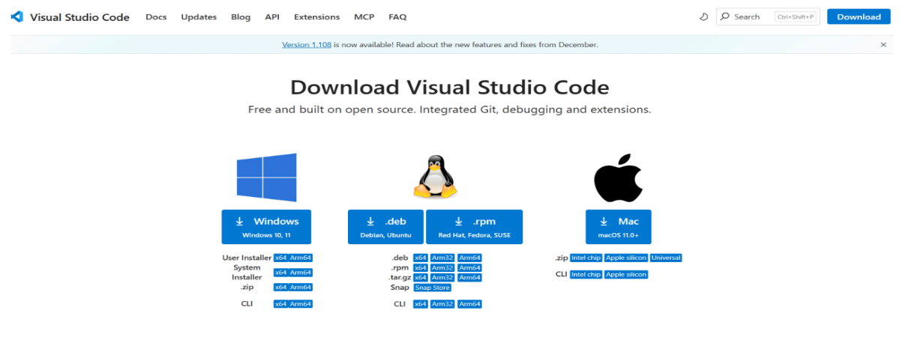
step – 2
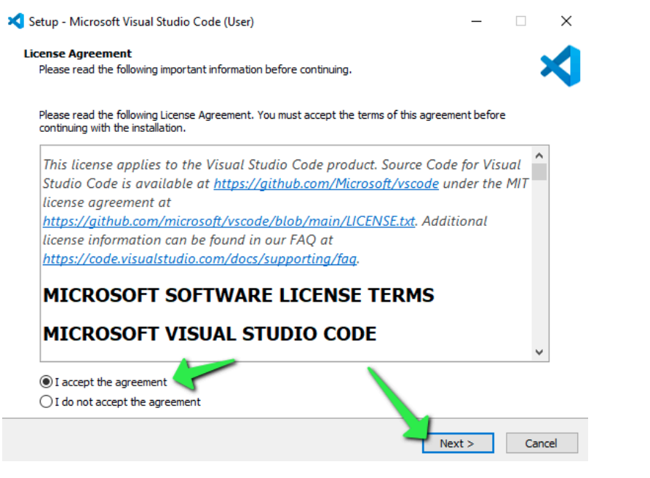

step -3
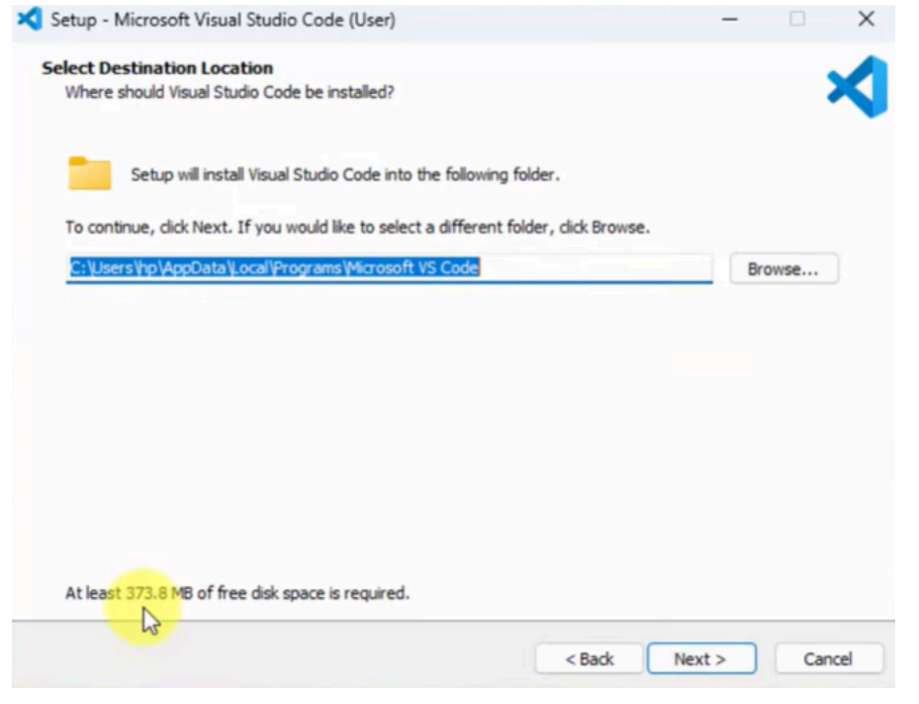
step – 4
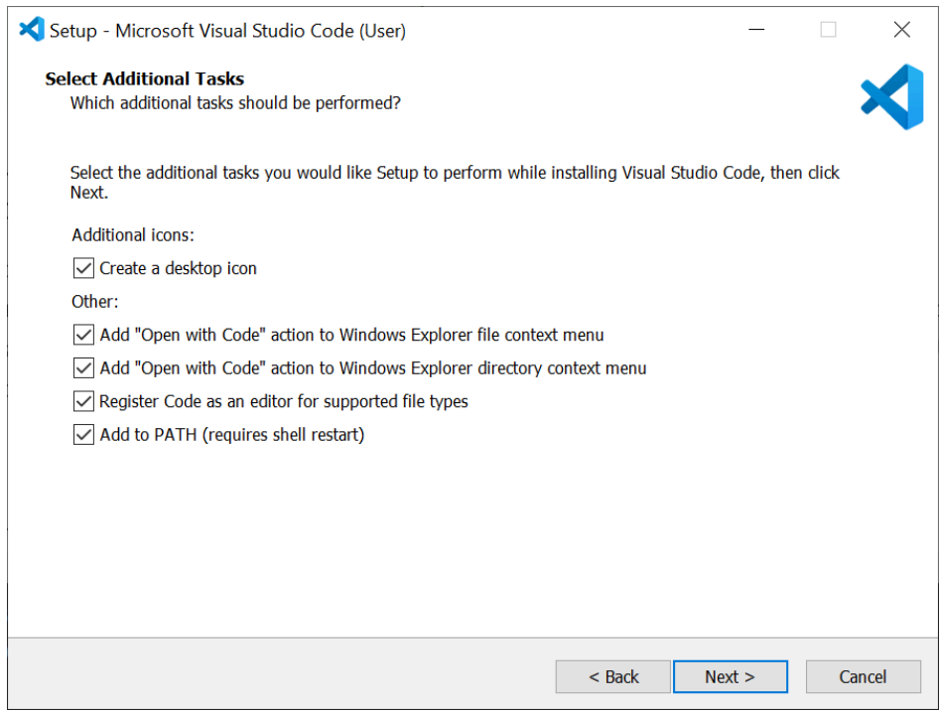
step – 5
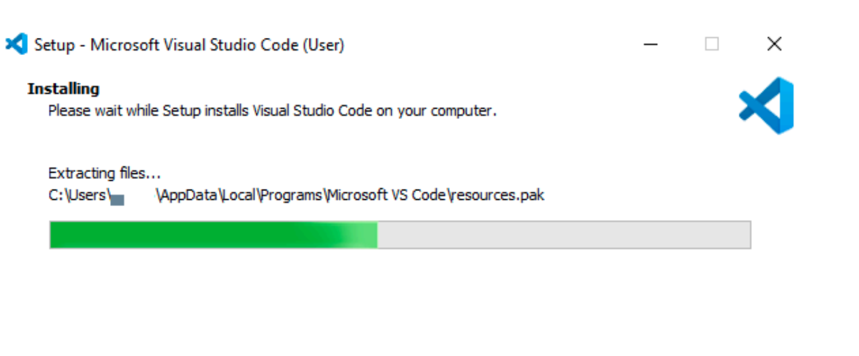
STEP-6
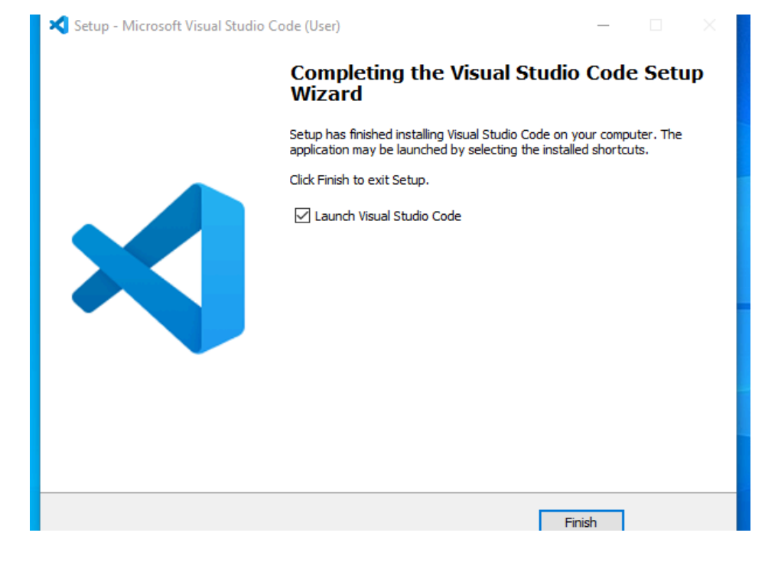
STEP 7:
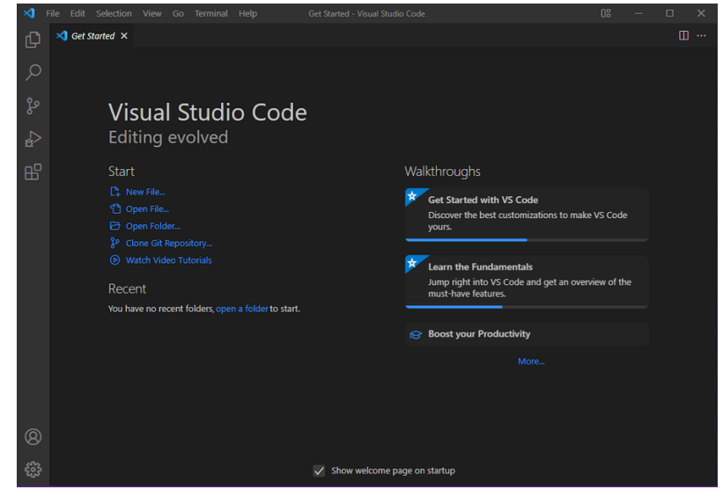

2.Understanding the structure of HTML a. Aim : To learn the basics of html( basics.html) Program:
<!DOCTYPE html>
<html>
<head>
<title>first web page</title>
</head>
<body>
<h1>happy to learn HTML</h1>
<p>this is my first sample code</p>
</body>
</html>

OUTPUT:
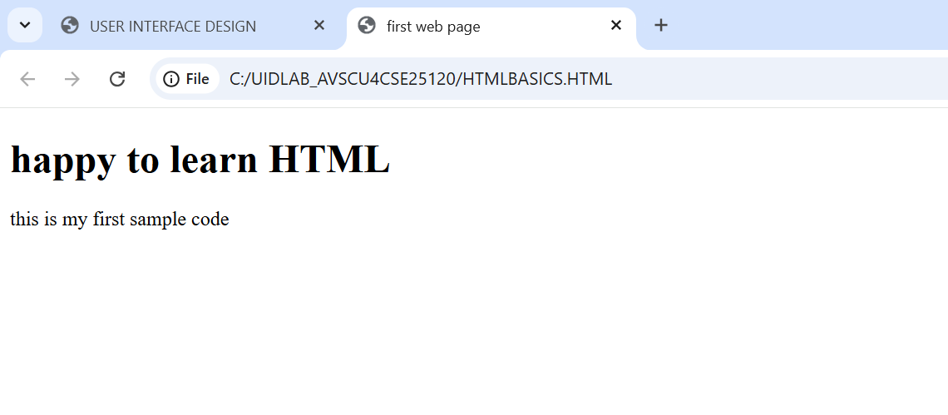

b. Aim: To learn headings in html( headings.html ) Program:
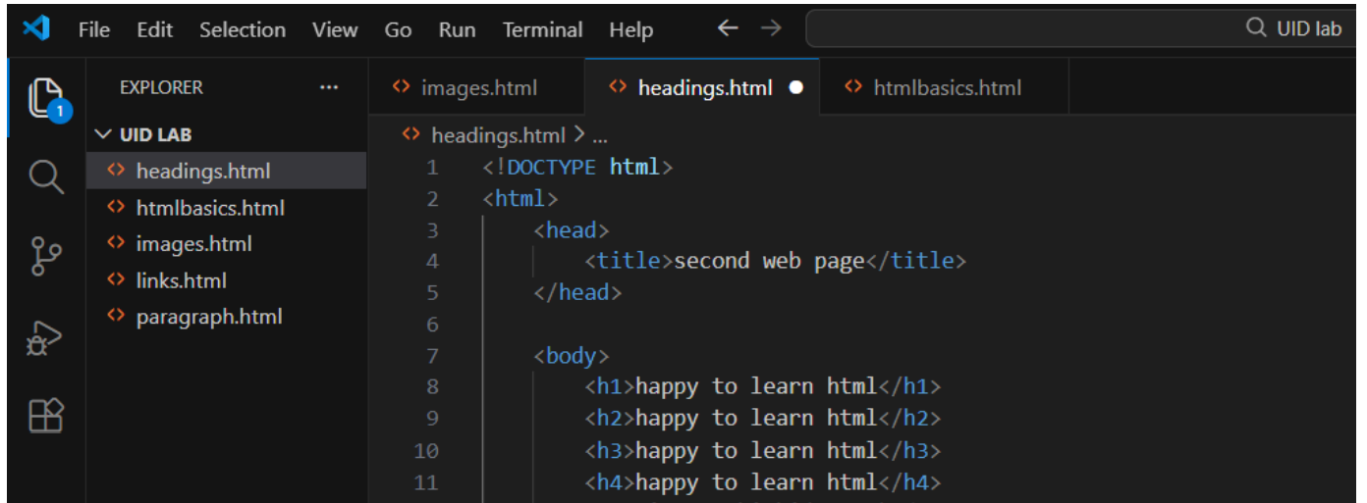
OUTPUT:
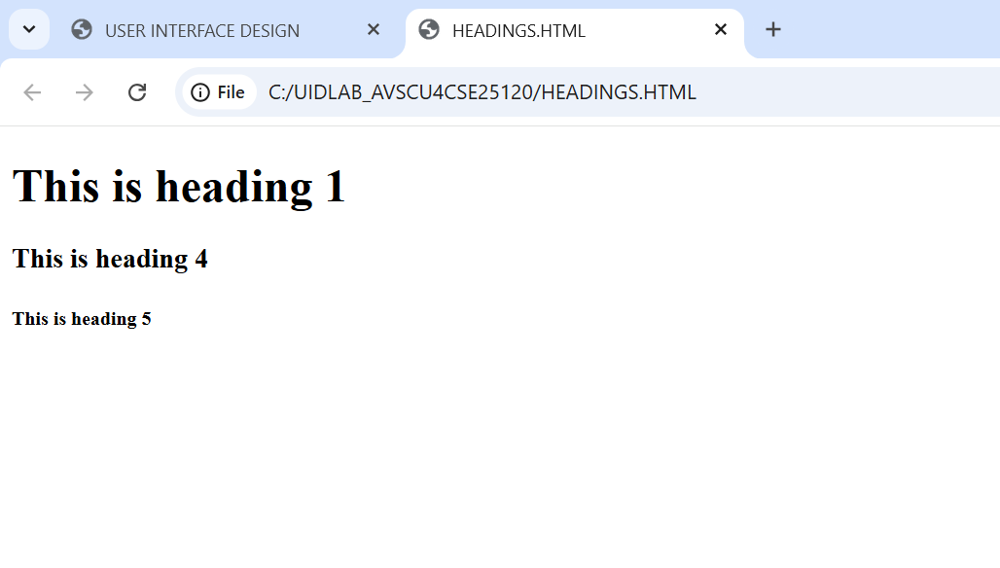

c. Aim: To learn writing a paragraph ( paragraph.html) Program:
<!DOCTYPE html>
<html>
<body>
<p>the given below details are my personals</p>
<p> i am gayathri studying my btech (25120)</p>
</body>

</html>

<!DOCTYPE html>
<html>
<body>

<p>the given below details are my personals</p>
<p>i am gayathri <br> studying my btech</p>
</body>
</html>

Output:
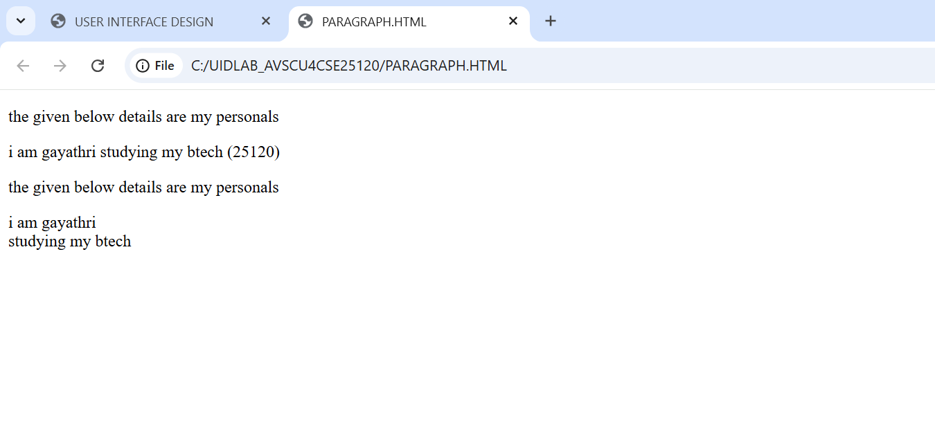
d. Aim: To learn opening links(links.html) Program:
<!DOCTYPE html>
<html>
<head>
<title>links</title>
</head>
<body>
<p> gayathri (25120)</p>
<p>this is the link to open w3schools</p>
<a href="https://www.W3schools.com">this is a link</a>
</p>
</body>
</html>

Output:
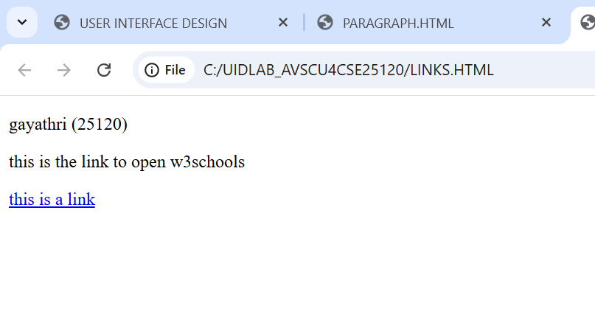
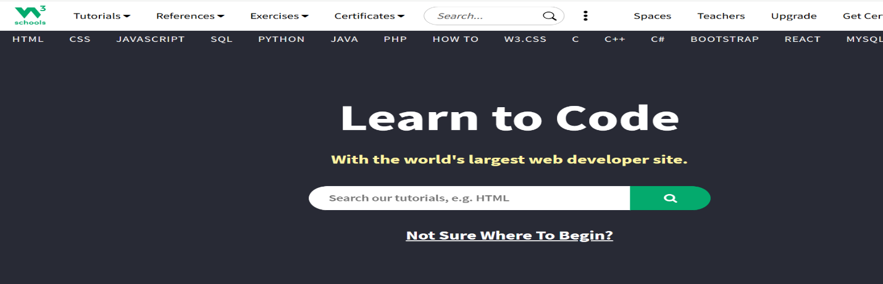
e. Aim: To learn to show images on web page (image.html ) Program:
<!DOCTYPE html>
<html>
<head>
<title>MS DHONI</title>
</head>
<body>
<h1> thala for a reason</h1>
<img src=https://media.gettyimages.com/id/1494318222/photo/final-chennai-super-kings-v-gujarat-titans.jpg?s=612x612&w=gi&k=20&c=yuUFkCBW8-NJQv4bFmt9nl_0lh05vvXHYkC27DGjDfc=>
</body>
</html>

Output: 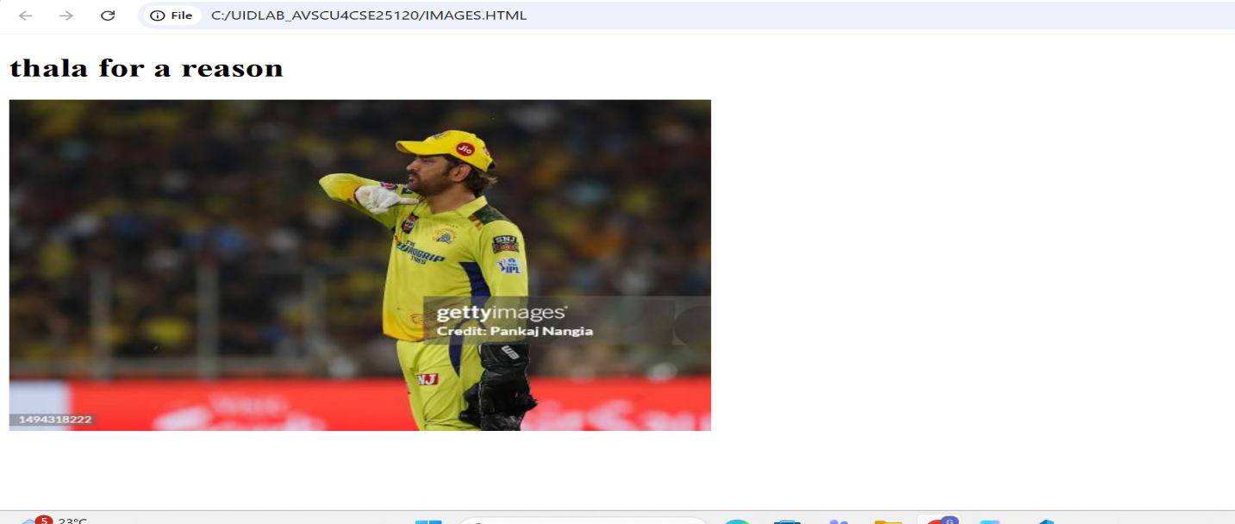

Explanation of the tags:
HTML stands for Hyper Text Markup Language.
HTML is used to create and structure web pages.
It tells the web browser what to display and how to display it.
<DOCTYPE HTML> : The element tells the browser , this is an HTML5 document
<html> : The element is the root element of an HTML page.
<head> : The element contains meta information about the HTML page.
<p>:the <p> element defines a paragraph.

Week-2
- Aim : To create a static webpage using HTML that displays basic information about Amrita Vishwa Vidyapeetham , including a heading,descriptive text , background styling through HTML attributes and a table showing the list of campusesin different states
Procedure:
- <!DOCTYPE html>
- <html>
- <head>
- <title>Amrita vishwa vidhyapeetam</title>
- </head>
- <body style="background-color:rgb(255, 244, 230);
- background-image:url(https://webfiles.amrita.edu/2022/03/nbElb5oz-amrita-amaravati-campus-banner-2022.jpg);
- background-size: cover ; background-repeat: no repeat;">
- <h1 style="text-align:center; color:rgb(0, 0, 0);border: 3px solid black;
- font-family: 'Times New Roman', Times, serif;"> Amrita vishwa vidhyapeetam</h1>
- <h2 style="text-align: center; color: black;font-family: 'Times New Roman', Times, serif;">
- Amaravathi Campus </h2><pre style="text-align: center;font-family: 'Times New Roman', Times, serif;color:rgb(226, 239, 237);
- font-size: large;">
- The Amrita Amaravati campus is a 200-acre, research-driven institution in Andhra Pradesh's greenfield capital.
- Accredited with a NAAC 'A++' grade and ranked among India's top 10 universities by NIRF 2025,
- it offers industry-aligned programs in Engineering, Management, and Sciences.
- Known for its "Education for Life" philosophy, the campus blends
- high-tech infrastructure with ethical values
- </pre>
- <table border="2"; align="center"; cellpadding="5";cellspacing="10"; width="60%";
- style="background-color:floralwhite;">
- <tr>
- <th>s.no</th>
- <th>campus</th>
<th>location</th>
- <th>number</th>
- <th>Link</th>
- </tr>
- <tr>
- <td>1.</td>
- <td >Amaravathi</td>
- <td >kuragallu</td>
- <td>+91-8645277800</td>
- <td >https://www.amrita.edu/campus/amaravati/</td>
- </tr>
- <tr>
- <td>2.</td>
- <td >coiambatore</td>
- <td >ettimadai</td>
- <td>+91-8645271800</td>
- <td >https://www.amrita.edu/campus/coiambatore/</td>
- </tr>
- <tr>
- <td>3.</td>
- <td >banglore</td>
- <td >junnasandra</td>
- <td>+91-8645272800</td>
- <td >https://www.amrita.edu/campus/banglore/</td>
- </tr>
- <tr>
- <td>4.</td>
- <td >amritapuri</td>
- <td >vallikavu</td>
- <td>+91-8645273800</td>
- <td >https://www.amrita.edu/campus//</td>
- </tr>
- </table>
- </body>
- </html>

OUTPUT:

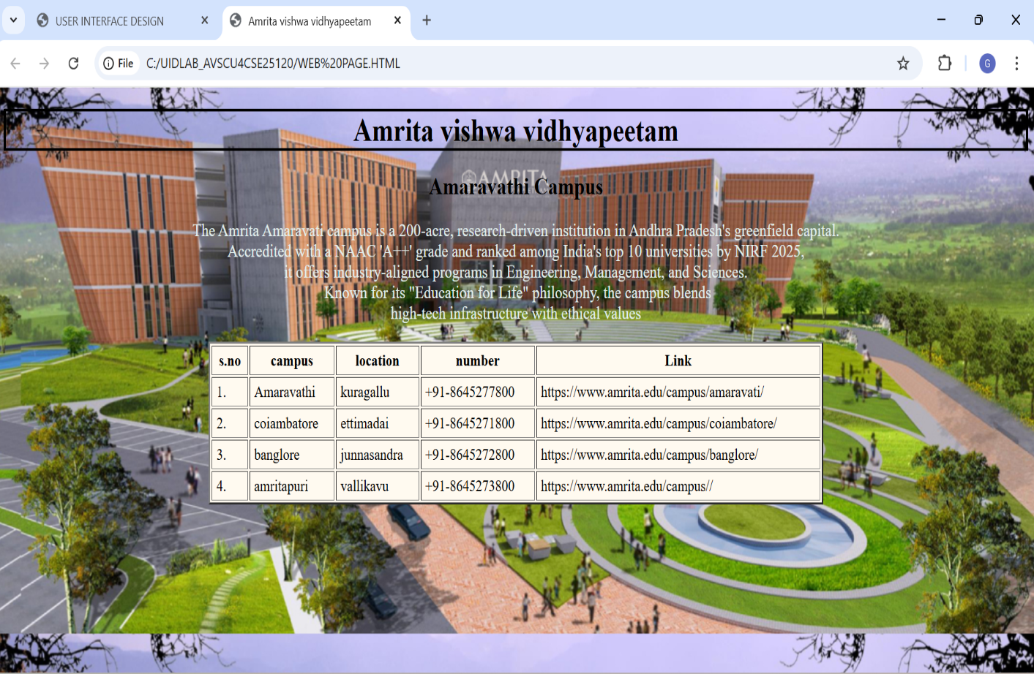

Explanation of the tags:

<h1>,<h2>– Heading tags for main title and subtitle.

<pre> – Displays text in preformatted style, preserving space and line breaks.

<table>– Createtable to arrange data in rows and columns.

Attributes: border, align, cellpadding, cellspacing, width.

<tr>– Defines a table row.
<th>– Table heading cell (bold and centered).

<td>– Table data cell for normal content.
Inline CSS (style attribute) – Used to set background color, image, font, alignment, and borders.

2.Aim : To design a webpage using HTML that demonstrated the use of background colour background image,heading styling and performatted text.

Procedure:

<!DOCTYPE html>
<html>
<head>
<title>Simple Web Page Demo</title>
<style>
/* Background color and image */
body {
background-color: antiquewhite; /* Background color */
background-image: url("https://wallpapers.com/images/hd/aesthetic-computer-pictures-yd6kon54y013rjzh.jpg");
background-repeat: no-repeat;
background-size: cover;
background-attachment: fixed;
font-family: Arial, sans-serif }
/* Heading styling */
h1 {
color: blueviolet;
text-align: center;
text-decoration: underline;
font-size: 40px; }
h2 { color: darkred;
margin-left: 20px;}
/* Paragraph styling */
p { font-size: 18px;
margin-left: 20px; }
/* Preformatted text styling */
pre {
background-color: white;
padding: 15px;
border: 2px solid black;
width: fit-content;
margin-left: 20px;}
</style>
</head>
<body>
<h1>Welcome to My Web Page</h1>
<h2>About This Page</h2>
<p>This page demonstrates background color, background image, heading styling, and preformatted text in HTML.</p>
<h2>Sample Preformatted Text</h2>
<pre>
Name : gayathri
Course : user interface design
College : Amrita University
</pre></body></html>

Output :
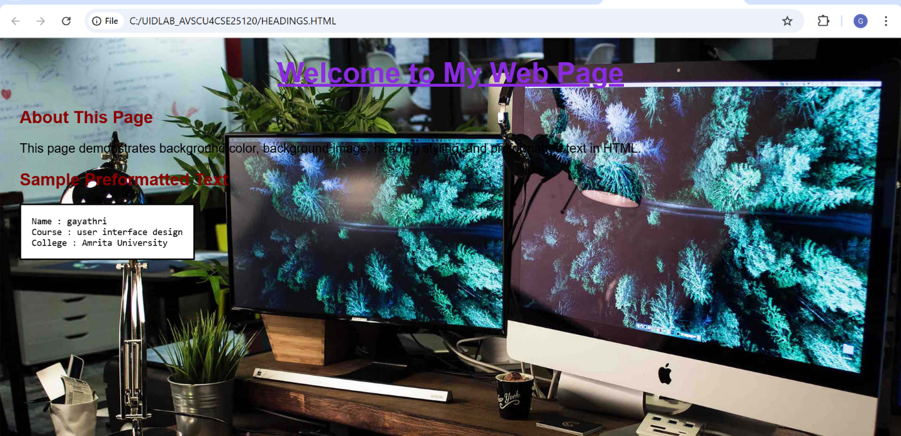

Explanation of the tags: h1>,
→ Headings
→ Paragraph
→ Preformatted text
2cAim: To design a restaurants menu webpage using HTML and displaying menu items in a table format with proper layout and visual styling.

Procedure :
<!DOCTYPE html>
<html>
<head>
<title>paradise restaurant - Luxury Edition</title>
<link href="https://fonts.googleapis.com/css2?family=Playfair+Display:ital@1&display=swap" rel="stylesheet">
<style>
body { margin: 0;
font-family: 'Playfair Display', serif;
background: url(https://imgmediagumlet.lbb.in/media/2025/03/67c59f4d2226626b47ecaf25_1741004621323.jpg) no-repeat center center fixed;
background-size: cover;
color: rgb(0, 255, 30);}
.header { background: rgba(0, 0, 0, 0.85);
text-align: center;
padding: 35px;
font-size: 40px;
letter-spacing: 3px;
font-style: italic;
color: rgb(21, 0, 255);
border-bottom: 3px solid; }
.menu-section { width: 85%;
margin: 40px auto;
padding: 25px;
border-radius: 15px;
background: rgba(0, 0, 0, 0.75);
box-shadow: 0 8px 25px rgba(0,0,0,0.8);
h2 { text-align: center;
font-style: italic;
font-size: 28px;
color: rgb(255, 0, 230);
border-bottom: 2px solid rgb(0, 0, 255);
padding-bottom: 10px; }
table {width: 100%;
border-collapse: collapse;
margin-top: 20px;
font-style: italic;}
th, td { padding: 14px;
text-align: center; }
th { color: rgb(255, 0, 221);
font-size: 20px;
border-bottom: 2px solid rgb(255, 140, 0); }
tr {background: transparent; }
tr:hover { background: rgba(0, 179, 255, 0.15);
transition: 0.3s; }
.price { color: #ff0000;
font-weight: bold; }
.footer { text-align: center;
padding: 20px;
background: rgba(0, 0, 0, 0.9);
color: rgb(0, 255, 149);
font-style: italic;
border-top: 2px solid rgb(255, 0, 30); }
</style>
</head>
<body>
<div class="header">
AHAARUCHI
⭐⭐⭐⭐⭐
</div><div class="menu-section">
<h2>Signature Starters</h2>
<table>
<tr>
<th>Item</th>
<th>Description</th>
<th>Price</th>
</tr>
<tr>
<td>Truffle Paneer Bites</td>
<td>Luxury grilled paneer infused with truffle essence</td>
<td class="price">₹320</td>
</tr> <tr>
<td>Royal Chicken Platter</td>
<td>Premium spiced chicken with exotic herbs</td>
<td class="price">₹450</td>
</tr> <tr>
<td>Golden Prawn Tempura</td>
<td>Crispy fried prawns served with signature sauce</td>
<td class="price">₹520</td>
</tr><tr>
<td>Herb Stuffed Mushrooms</td>
<td>Baked mushrooms filled with creamy herbs</td>
<td class="price">₹300</td>
</tr> <tr>
<td>Cheese Stuffed Jalapeños</td>
<td>Spicy jalapeños filled with rich cheese</td>
<td class="price">₹280</td>
</tr>
</table>
</div>
<div class="menu-section">
<h2>Chef’s Special Entrées</h2>
<table> <tr>
<th>Item</th>
<th>Description</th>
<th>Price</th> </tr>
<tr> <td>Imperial Mutton Biryani</td>
<td>Slow-cooked aromatic rice with premium mutton</td>
<td class="price">₹550</td> </tr>
<tr> <td>Golden Cream Pasta</td>
<td>Rich Alfredo sauce with fine herbs</td>
<td class="price">₹380</td> </tr>
<tr> <td>Grilled Salmon Steak</td>
<td>Fresh salmon grilled to perfection</td>
<td class="price">₹650</td> </tr>
<tr> <td>Royal Butter Chicken</td>
<td>Creamy tomato gravy with tender chicken</td>
<td class="price">₹480</td> </tr>
<tr> <td>Luxury Veg Lasagna</td>
<td>Layered pasta with cheese and vegetables</td>
<td class="price">₹420</td> </tr>
</table></div>
div class="menu-section">
<h2>Luxury Desserts</h2>
<table>
<tr> <th>Item</th>
<th>Description</th>
<th>Price</th>
</tr><tr>
<td>Belgian Chocolate Delight</td>
<td>Premium dark chocolate layered dessert</td>
<td class="price">₹290</td>
</tr> <tr>
<td>Royal Saffron Kulfi</td>
<td>Traditional saffron-infused frozen dessert</td>
<td class="price">₹220</td>
</tr> <tr>
<td>Strawberry Cheesecake</td>
<td>Creamy cheesecake topped with strawberries</td>
<td class="price">₹310</td>
</tr> <tr>
<td>Tiramisu Classic</td>
<td>Italian layered coffee-flavored dessert</td>
<td class="price">₹350</td>
</tr></table>
</div>
div class="menu-section">
<h2>Premium Beverages</h2>
<table> <tr> <th>Item</th>
<th>Description</th>
<th>Price</th></tr>
<tr> <td>Fresh Fruit Mocktail</td>
<td>Blend of seasonal fruits with sparkling soda</td>
<td class="price">₹190</td> </tr>
<tr> <td>Classic Cappuccino</td>
<td>Rich espresso topped with frothy milk</td>
<td class="price">₹160</td>
</tr> <tr>
<td>Blue Lagoon</td>
<td>Refreshing citrus drink with blue curacao flavor</td>
<td class="price">₹210</td>
</tr> <tr><td>Mint Mojito</td>
<td>Fresh mint with lime and soda</td>
<td class="price">₹170</td></tr>
</table>
</div><div class="footer">
Experience Luxury Dining | Contact: 9727727180
</div>
</body>
</html>
Output:
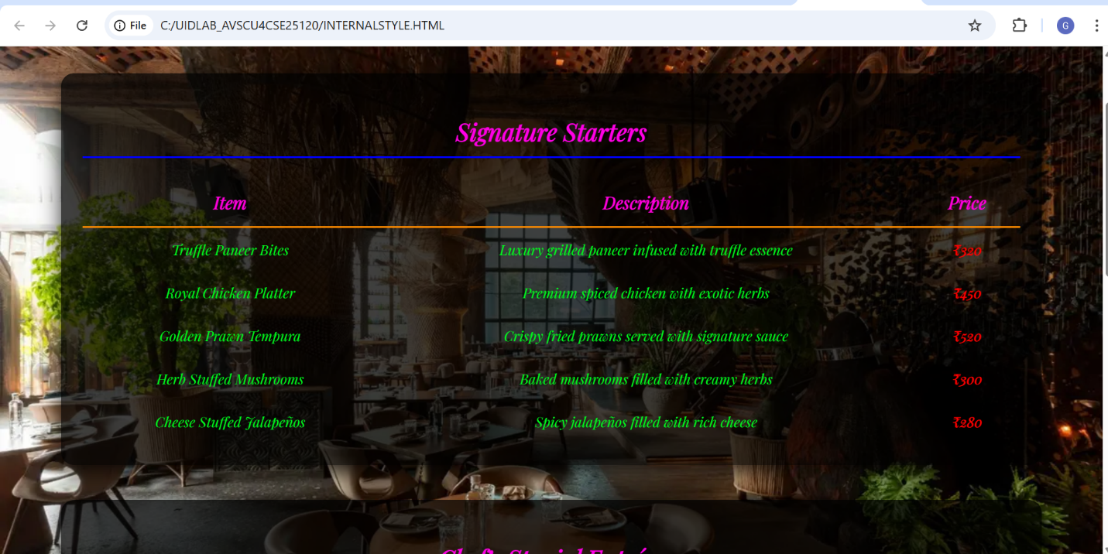

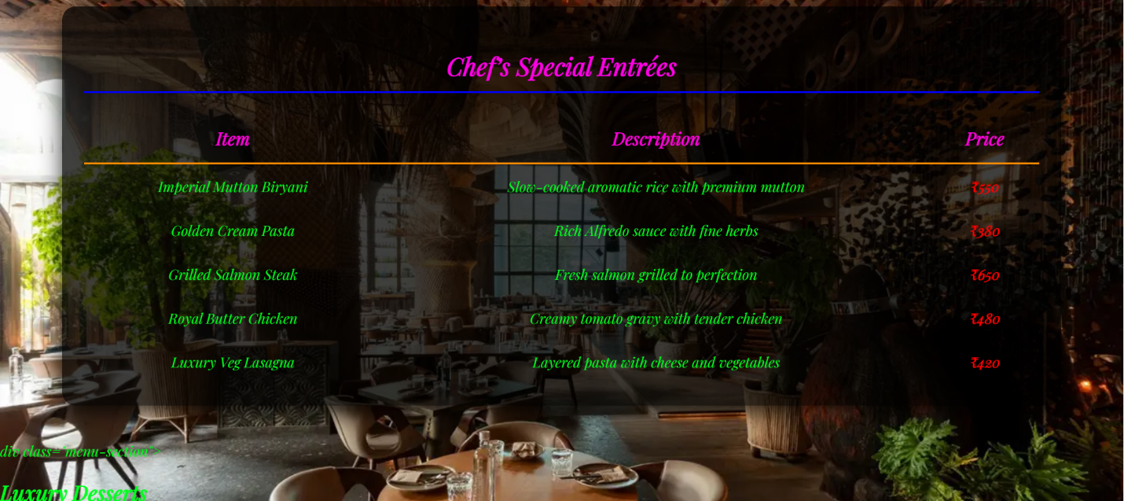

Week-3
- Aim: Construction of Class Timetable using html Elements
Program:
<!DOCTYPE html>
<html>
<head>

<title>CSE-B Semester II Timetable</title>
<style>
table { width: 100%; border-collapse: collapse; font-family: Arial, sans-serif; }
th, td { border: 1px solid #444; padding: 8px; text-align: center; font-size: 12px; }
th { background-color: #f2f2f2; }
.break { background-color: #e8e8e8; font-style: italic; }
.header-info { margin-bottom: 20px; }
</style>
</head>
<body>

<div class="header-info">
<h2>Dept. CSE - Class: B. Tech. CSE-B (Sem-II)</h2>
<p><strong>Venue:</strong> Room 511</p>
<p><strong>Class Advisors:</strong> Dr. K.G.R. Narayan & Dr. Ankit Sachan</p>
</div>

<table>
<thead>
<tr>
<th>Time / Day</th>
<th>08.55-10.35 (Slot 1 & 2)</th>
<th>10.35-10.45</th>
<th>10.45-11.35 (Slot 3)</th>
<th>11.35-12.25 (Slot 4)</th>
<th>12.25-01.15 (Slot 5)</th>
<th>01.15-02.05</th>
<th>02.10-03.00 (Slot 6)</th>
<th>03.10-04.50 (Slot 7 & 8)</th>
</tr>
</thead>
<tbody>
<tr>
<td><strong>Monday</strong></td>
<td>23MAT117 Linear Algebra LAB</td>
<td class="break">Short Break</td>
<td>LIBRARY</td>
<td>23PHY115 Modern Physics</td>
<td>LIBRARY</td>
<td class="break">Lunch</td>
<td colspan="2">23MEE115 Manufacturing Practice LAB</td>
</tr>
<tr>
<td><strong>Tuesday</strong></td>
<td>23MAT116 Discrete Math / 23MAT117 Linear Algebra</td>
<td class="break">Short Break</td>
<td>23PHY115 Modern Physics</td>
<td>23CSE111 Object Oriented Programming</td>
<td>23CSE113 User Interface Design</td>
<td class="break">Lunch</td>
<td>Library/Sports</td>
<td>22ADM111 Glimpses of Glorious India</td>
</tr>
<tr>
<td><strong>Wednesday</strong></td>
<td>Prog Lab 2 / 23CSE111 Object Oriented</td>
<td class="break">Short Break</td>
<td>23MAT116 Discrete Mathematics</td>
<td>23CSE113 User Interface Design</td>
<td>22ADM111 Glimpses of Glorious India</td>
<td class="break">Lunch</td>
<td>COUNSELLING</td>
<td>Library/Sports</td>
</tr>
<tr>
<td><strong>Thursday</strong></td>
<td>23CSE111 OOP / 23MAT117 Linear Algebra</td>
<td class="break">Short Break</td>
<td>23MAT116 Discrete Mathematics</td>
<td>COUNSELLING</td>
<td>LIBRARY</td>
<td class="break">Lunch</td>
<td>23PHY115 Modern Physics (T)</td>
<td>Library/Sports</td>
</tr>
<tr>
<td><strong>Friday</strong></td>
<td>23CSE113 UI Design Lab (BYOD)</td>
<td class="break">Short Break</td>
<td>23MAT117 Linear Algebra</td>
<td>23CSE111 Object Oriented Programming</td>
<td>Library/Sports</td>
<td class="break">Lunch</td>
<td>22ADM111 Glimpses of India (P)</td>
<td>23MAT116 Discrete Math Lab</td>
</tr>
</tbody>
</table>

</body>
</html>

Output:
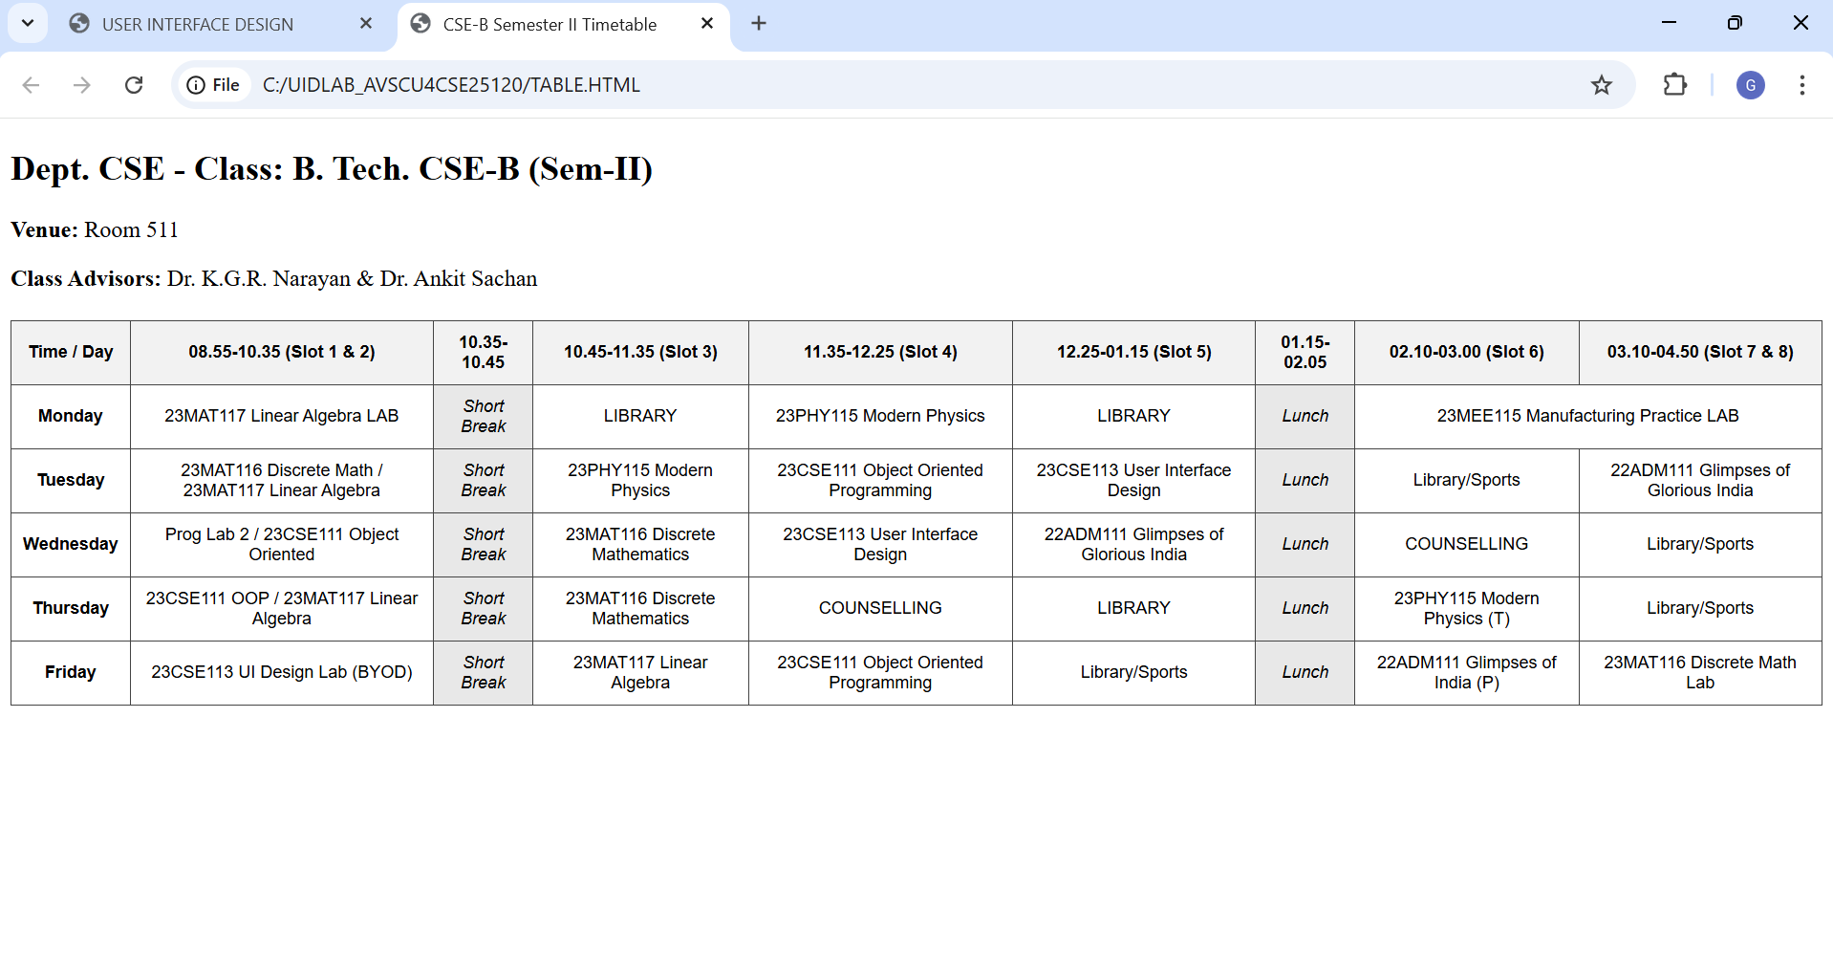

Explanation of the tags
<table>: is used to create the timetable structure with borders and spacing.
<tr>:defines table rows for each day.
<th>:is used for headings like time slots and days.
<td>:is used for headings like time slots and days. : is used to enter subjects and activities.
colspan :merges columns for lab hours.
rowspan : merges rows for short break and lunch break.
bgcolor :gives background color to break cells. class="vertical" : applies vertical text style.
style attribute changes text color for specific cells.

2 . Aim: Construction of web page Displaying Each Syllabus of each Subject Displaying as Image Format and also displaying the Corresponding time table of current semester
Program:
UIDLAB-CSE25120
<!DOCTYPE html>
<html>
<head>
<title>Syllabus, Faculty & Master Time Table</title>
<style>
body{
font-family: Arial;
background-color: #f2f6ff;
text-align: center;
}
h2{
margin: 25px 0 15px 0;
}
/* Gallery */
.gallery{
display: grid;
grid-template-columns: 1fr 1fr ;
gap: 25px;
width: 90%;
margin: auto;
}
.card{
background-color: white;
padding: 10px;
border-radius: 10px;
border: 2px solid black;
}
.card img{
width: 100%;
border-radius: 8px;
}
.title{
font-weight: bold;
font-size: 18px;
margin: 8px 0;
}
.faculty{
color: #333;
margin-bottom: 8px;
}
/* Tables */
table{
border-collapse: collapse;
margin: 30px auto;
background-color: white;
width: 95%;
}
th{
background-color: #dbe4f2;
}
td, th{
border: 1px solid black;
padding: 8px;
text-align: center;
}
.break{
background-color: yellow;
font-weight: bold;
}
.vertical {
writing-mode: vertical-rl;
transform: rotate(180deg);
text-align: center;
font-weight: bold;
letter-spacing: 2px;
}
</style>
</head>
<body>
<h2>SUBJECT SYLLABUS & FACULTY</h2>
<div class="gallery">
<div class="card">
<div class="title">23MAT116 – Discrete Mathematics</div>
<div class="faculty">Faculty: Dr. Srivasa Rao Thota</div>
<img src="C:\Users\Divya\OneDrive\Desktop\UID lab\syllabusproject\img1.png.png">
</div>
<div class="card">
<div class="title">23MAT117 – Linear Algebra</div>
<div class="faculty">Faculty: Mr. Sapavat Bixapathi</div>
<img src="C:\Users\Divya\OneDrive\Desktop\UID lab\syllabusproject\img2.png.png">
</div>
<div class="card">
<div class="title">23CSE111 – Object Oriented Programming</div>
<div class="faculty">Faculty: Dr. Balaji TK</div>
<img src="C:\Users\Divya\OneDrive\Desktop\UID lab\syllabusproject\img3.png.png">
</div>
<div class="card">
<div class="title">23PHY115 – Modern Physics</div>
<div class="faculty">Faculty: Dr. C R Kesavalu</div>
<img src="C:\Users\Divya\OneDrive\Desktop\UID lab\syllabusproject\img4.png.png">
</div>
<div class="card">
<div class="title">23CSE113 – User Interface Design</div>
<div class="faculty">Faculty: Dr. Rajkumar Batchu<br>Assisting: Mr. Barge Bharadwaj</div>
<img src="C:\Users\Divya\OneDrive\Desktop\UID lab\syllabusproject\img5.png.png">
</div>
<div class="card">
<div class="title">23MEE115 – Manufacturing Practice Lab</div>
<div class="faculty">Faculty: Dr. Sathies S.</div>
<img src="C:\Users\Divya\OneDrive\Desktop\UID lab\syllabusproject\img6.png.png">
</div>
</div>
<h2 align="center">Master Time Table CSE II Semester B Section</h2>
<table border="1" cellspacing="0" cellpadding="8" align="center">
<tr>
<th>Time / Day</th>
<th>Slot 1<br>08:55–09:45</th>
<th>Slot 2<br>09:45–10:35</th>
<th>10:35–10:45</th>
<th>Slot 3<br>10:45–11:35</th>
<th>Slot 4<br>11:35–12:25</th>
<th>Slot 5<br>12:25–01:15</th>
<th>01:15–02:05</th>
<th>Slot 6<br>02:10–03:00</th>
<th>03:00–03:10</th>
<th>Slot 7<br>03:10–04:00</th>
<th>Slot 8<br>04:00–04:50</th>
</tr>
<tr>
<th>Monday</th>
<td colspan="2">23MAT117 Linear Algebra LAB (BYOD)</td>
<td rowspan="5" bgcolor="lightgreen" class="vertical">SHORT BREAK</td>
<td>LIBRARY</td>
<td>23PHY115 Modern Physics</td>
<td>LIBRARY</td>
<td rowspan="5" bgcolor="lightgreen" class="vertical">LUNCH BREAK</td>
<td>23MEE115 Manufacturing Practice LAB</td>
<td rowspan="5" bgcolor="lightgreen" class="vertical">SHORT BREAK</td>
<td colspan="2">23MEE115 Manufacturing Practice LAB</td>
</tr>
<tr>
<th>Tuesday</th>
<td>23MAT116 Discrete Mathematics</td>
<td>23MAT117 Linear Algebra</td>
<td>23PHY115 Modern Physics</td>
<td>23CSE111 Object Oriented Programming</td>
<td>23CSE113 User Interface Design</td>
<td>Library/Sports</td>
<td colspan="2">22ADM111 Glimpses of Glorious India</td>
</tr>
<tr>
<th>Wednesday</th>
<td colspan="2">23CSE111 OOPS Lab</td>
<td>23MAT116 Discrete Mathematics</td>
<td>23CSE113 User Interface Design</td>
<td>22ADM111 Glimpses of Glorious India</td>
<td style="color:sandybrown;">COUNSELLING</td>
<td colspan="2">Library/Sports</td>
</tr>
<tr>
<th>Thursday</th>
<td>23MAT117 Linear Algebra</td>
<td>23CSE111 Object Oriented Programming</td>
<td>23MAT116 Discrete Mathematics</td>
<td style="color:sandybrown;">COUNSELLING</td>
<td>LIBRARY</td>
<td>23PHY115 Modern Physics (T)</td>
<td colspan="2">Library/Sports</td>
</tr>
<tr>
<th>Friday</th>
<td colspan="2">23CSE113 User Interface Design Lab BYOD</td>
<td>23MAT117 Linear Algebra</td>
<td>23CSE111 Object Oriented Programming</td>
<td>Library/Sports</td>
<td>22ADM111 Glimpses of Glorious India (P)</td>
<td colspan="2">23MAT116 Discrete Mathematics Lab</td>
<tr>
<th colspan="1">Course Code</th>
<th colspan="3">Course Name</th>
<th>L-T-P</th>
<th>Credits</th>
<th colspan="3">Faculty Name</th>
<th colspan="3">Assisting Faculty</th>
</tr>
<tr>
<td colspan="1">23MAT116</td>
<td colspan="3">Discrete Mathematics</td>
<td>3-0-2</td>
<td>4</td>
<td colspan="3">Dr. Srivasa Rao Thota</td>
<td colspan="3"></td>
</tr>
<tr>
<td colspan="1">23MAT117</td>
<td colspan="3">Linear Algebra</td>
<td>3-0-2</td>
<td>4</td>
<td colspan="3">Mr. Sapavat Bixapathi</td>
<td colspan="3"></td>
</tr>
<tr>
<td colspan="1">23CSE111</td>
<td colspan="3">Object Oriented Programming</td>
<td>3-0-2</td>
<td>4</td>
<td colspan="3">Dr. Balaji TK</td>
<td colspan="3" ></td>
</tr>
<tr>
<td colspan="1">23PHY115</td>
<td colspan="3">Modern Physics</td>
<td>2-1-0</td>
<td>3</td>
<td colspan="3">Dr. C R Kesavalu</td>
<td colspan="3"></td>
</tr>
<tr>
<td colspan="1">23CSE113</td>
<td colspan="3">User Interface Design</td>
<td>2-0-2</td>
<td>3</td>
<td colspan="3">Dr. Rajkumar Batchu</td>
<td colspan="3">Mr. Barge Bharadwaj</td>
</tr>
<tr>
<td colspan="1">23MEE115</td>
<td colspan="3">Manufacturing Practice</td>
<td>0-0-3</td>
<td>1</td>
<td colspan="3">Dr. Sathies S.</td>
<td colspan="3"></td>
</tr>
<tr>
<td colspan="1">22ADM111</td>
<td colspan="3">Glimpses of Glorious India</td>
<td>2-0-1</td>
<td>2</td>
<td colspan="3">Dr. Siva Panuganti</td>
<td colspan="3"></td>
</tr>
</table>
</body>
</html>

OUTPUT:
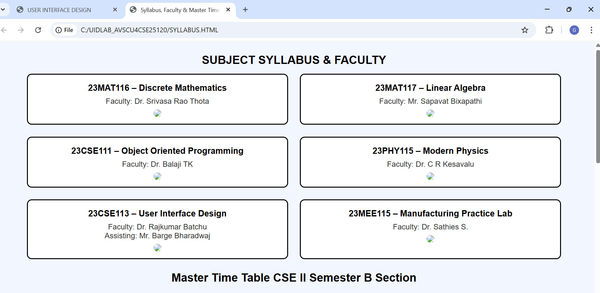
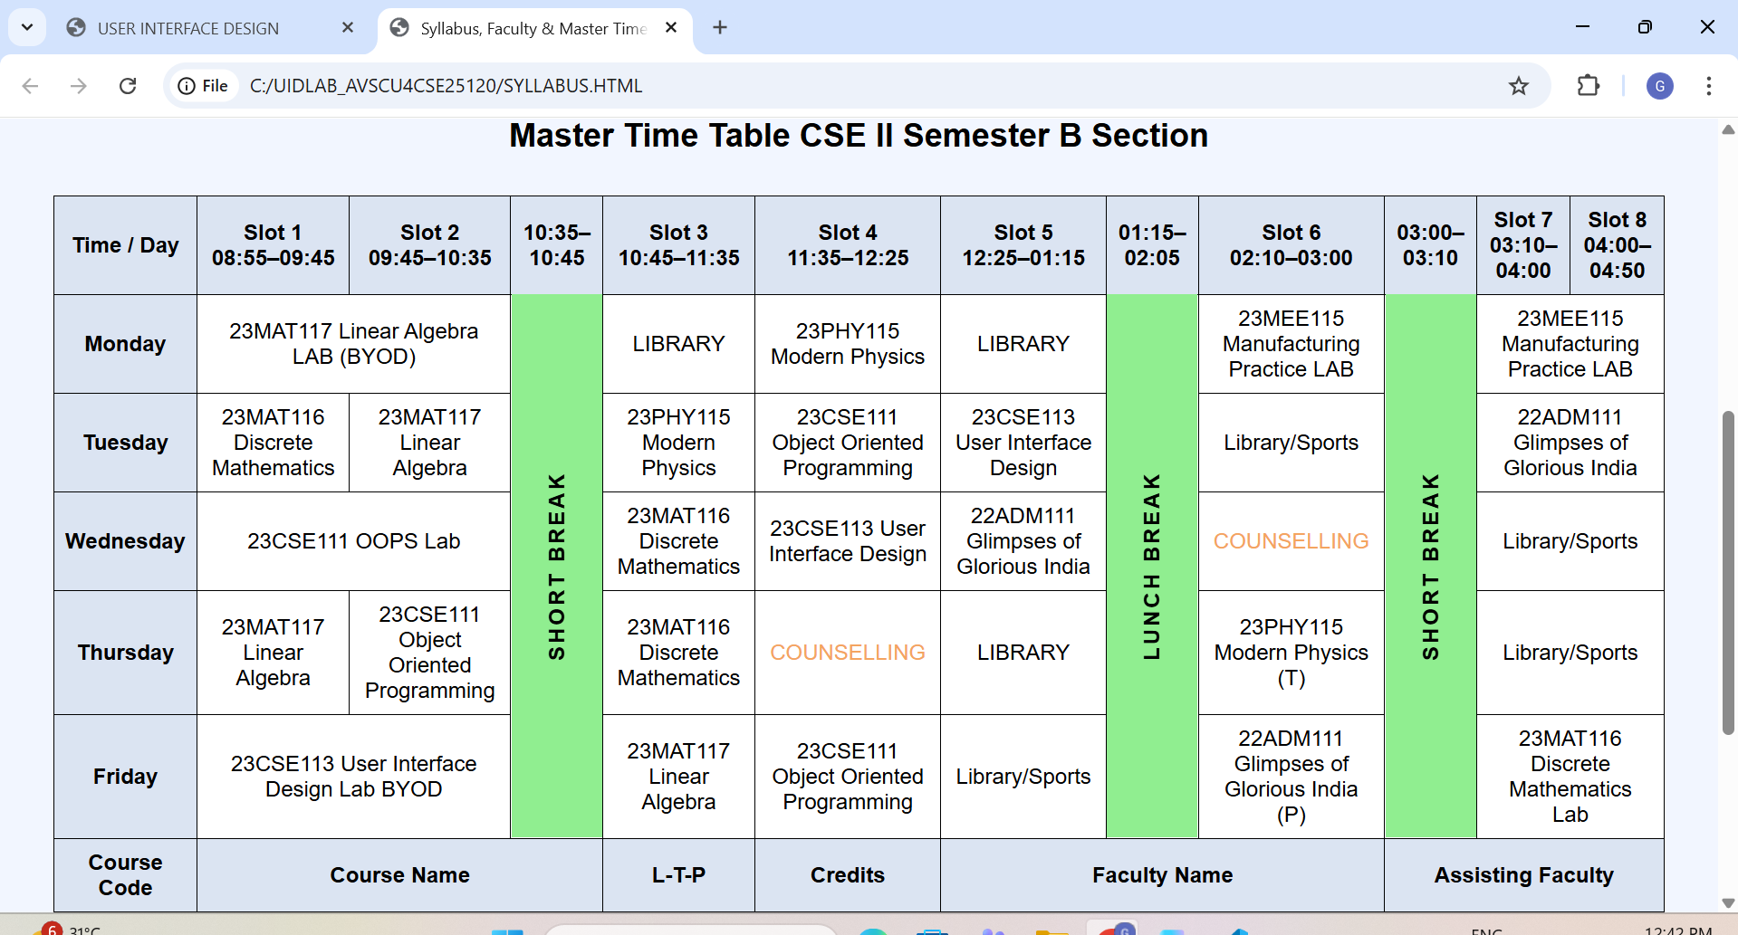

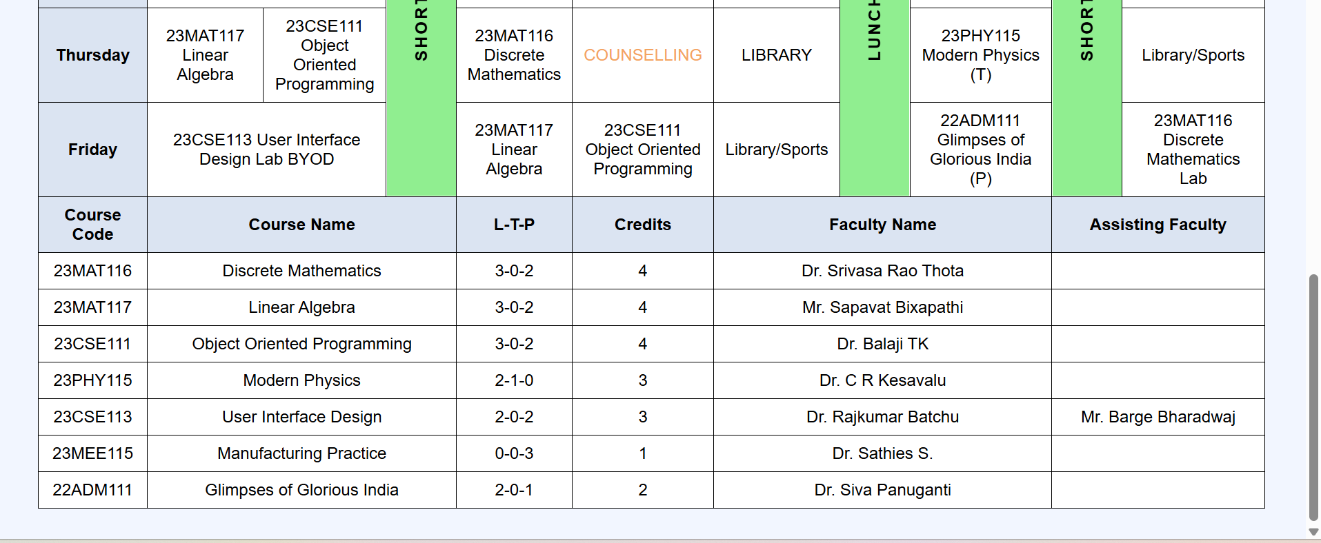

Explanation of the tags:
<div>: is used as a container to group content like gallery and cards.
<img>: tag is used to display syllabus images using the src attribute.
CSS classes like .gallery, .card, .title, .faculty, and .break are introduced for styling.
display : grid is used to create a two-column gallery layout.
margin : auto centers the content on the page. border-radius is used to give rounded corners to cards and images. border-collapse : collapse makes the table borders neat.
font-family changes the text style of the whole page.
Combined selector td, th applies common styles. HTML comments <!-- -->are used to organize the code into sections.

Week-4
1 . Aim : A college wants to collect student details through an online admission form design a registration form using only html tags(no css) with propern labels table alignment,background color and borders Procedure :
<!DOCTYPE html>
<html>
<head>
<title>College Online Admission Form</title>
<style>
/* Styles for the pop-up (Modal) */
#successModal {
display: none; /* Hidden by default */
position: fixed;
z-index: 1;
left: 0;
top: 0;
width: 100%;
height: 100%;
background-color: rgba(0,0,0,0.5); /* Black background with opacity */
}

.modal-content {
background-color: #ffffff;
margin: 15% auto;
padding: 20px;
border: 1px solid #888;
width: 30%;
text-align: center;
border-radius: 10px;
box-shadow: 0 4px 8px rgba(0,0,0,0.2);
}

.close-btn {
background-color: #4CAF50;
color: white;
padding: 10px 20px;
border: none;
border-radius: 5px;
cursor: pointer;
margin-top: 15px;
}
</style>

<script>
function showPopup(event) {
// Stop the page from refreshing
event.preventDefault();

// Show the hidden modal div
document.getElementById("successModal").style.display = "block";
return false;
}

function closePopup() {
// Hide the modal and reset the form
document.getElementById("successModal").style.display = "none";
document.getElementById("admissionForm").reset();
}
</script>
</head>

<body bgcolor="#e6f2ff">

<h2 align="center">COLLEGE ONLINE ADMISSION FORM</h2>

<form id="admissionForm" onsubmit="return showPopup(event)">
<table border="2" align="center" cellpadding="8" cellspacing="0" width="70%" bgcolor="#ffffff">

<tr>
<td colspan="2" align="center" bgcolor="#d1e0f0"><b>Student Personal Details</b></td>
</tr>

<tr>
<td><label for="fname">First Name:</label></td>
<td><input type="text" id="fname" name="fname" required></td>
</tr>

<tr>
<td><label for="lname">Last Name:</label></td>
<td><input type="text" id="lname" name="lname" required></td>
</tr>

<tr>
<td><label for="dob">Date of Birth:</label></td>
<td><input type="date" id="dob" name="dob" required></td>
</tr>

<tr>
<td><label>Gender:</label></td>
<td>
<input type="radio" name="gender" value="male"> Male
<input type="radio" name="gender" value="female"> Female
<input type="radio" name="gender" value="other"> Other
</td>
</tr>

<tr>
<td><label for="email">Email ID:</label></td>
<td><input type="email" id="email" name="email" required></td>
</tr>

<tr>
<td><label for="phone">Mobile Number:</label></td>
<td><input type="tel" id="phone" name="phone" required></td>
</tr>

<tr>
<td><label for="address">Address:</label></td>
<td><textarea id="address" name="address" rows="4" cols="30"></textarea></td>
</tr>

<tr>
<td><label for="course">Course Applying For:</label></td>
<td>
<select id="course" name="course">
<option>B.Tech</option>
<option>B.Sc</option>
<option>B.Com</option>
<option>BCA</option>
<option>MCA</option>
</select>
</td>
</tr>

<tr>
<td><label for="marks">12th Marks (%):</label></td>
<td><input type="number" id="marks" name="marks"></td>
</tr>

<tr>
<td><label>Hobbies:</label></td>
<td>
<input type="checkbox" name="hobby"> Reading
<input type="checkbox" name="hobby"> Sports
<input type="checkbox" name="hobby"> Music
</td>
</tr>

<tr>
<td><label for="photo">Upload Photo:</label></td>
<td><input type="file" id="photo" name="photo"></td>
</tr>

<tr>
<td colspan="2" align="center">
<input type="submit" value="Submit" style="cursor:pointer">
<input type="reset" value="Reset" style="cursor:pointer">
</td>
</tr>

</table>
</form>

<div id="successModal">
<div class="modal-content">
<h2 style="color: #4CAF50;">Success!</h2>
<p>Your admission form has been submitted successfully.</p>
<button class="close-btn" onclick="closePopup()">OK</button>
</div>
</div>

</body>
</html>
Output:
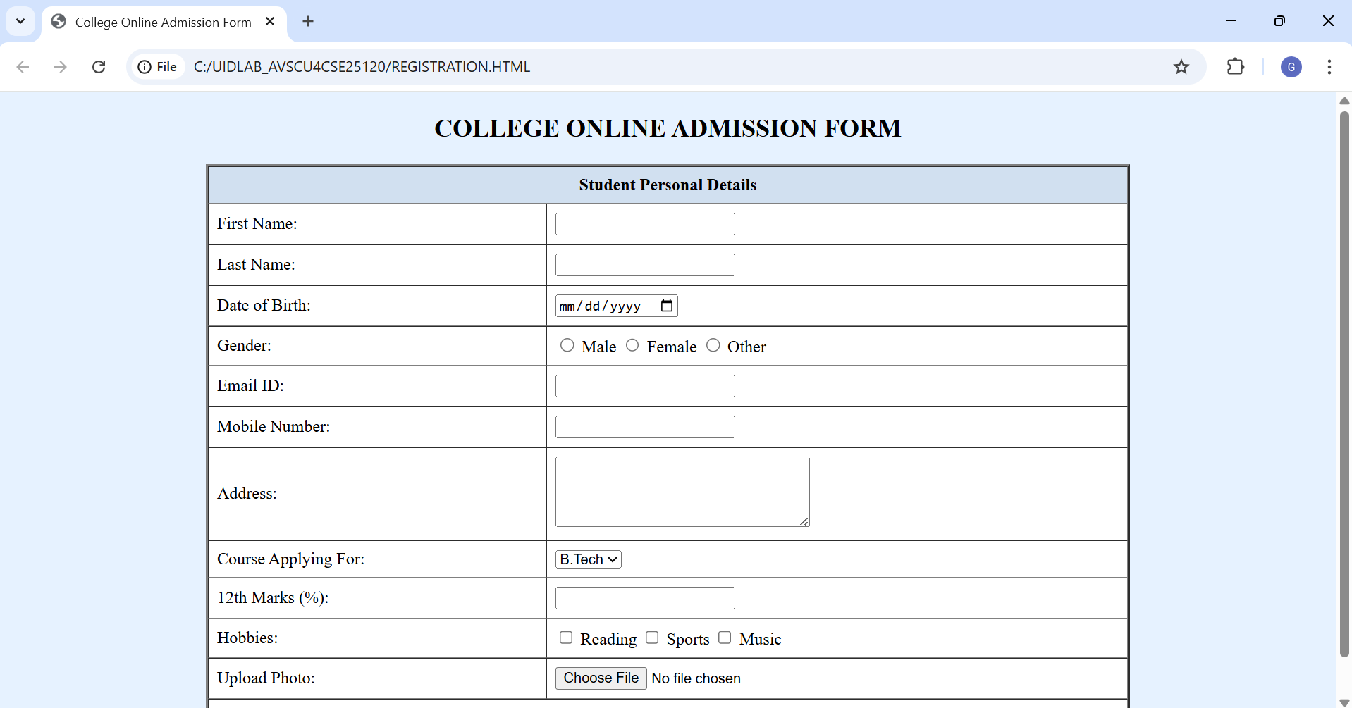

Explanation of the tags:

<form>– Collects user input
colspan – Merges two columns into one
<label for>. – Labels input fields. – Takes user input (text, date, radio, email, tel, number, file, reset).
<textarea>– Multi-line text input. & –
<select>&<option> Dropdown list. checkbox – Multiple selections. – Shows alert message. Attributes: id, name, align, bgcolor, rows, cols, border, width – control layout and identification.

2 . AIM: A Company wants to design a webpage that display two different forms side by side using iframes in which one should display a login form and other should display register form
Program :
<!DOCTYPE html>
<html>
<head>
<title>Login Form</title>
</head>
<body bgcolor="#e6f2ff">
<h2 align="center">Login Form</h2>
<form align="center">
<table border="1" cellpadding="8" align="center">
<tr>
<td>Username:</td>
<td><input type="text" name="uname"></td>
</tr>
<tr>
<td>Password:</td>
<td><input type="password" name="pass"></td>
</tr>
<tr>
<td colspan="2" align="center">
<input type="submit" value="Login">
</td>
</tr>
</table>
</form>
</body>
</html>
<______Register form_______>
<!DOCTYPE html>
<html>
<head>
<title>Register Form</title>
</head>
<body bgcolor="#fff0e6">
<h2 align="center">Register Form</h2>
<form align="center">
<table border="1" cellpadding="8" align="center">
<tr>
<td>Full Name:</td>
<td><input type="text" name="fname"></td>
</tr>
<tr>
<td>Email:</td>
</head>
<body>
<td><input type="email" name="email"></td>
</tr>
<tr>
<td>Password:</td>
<td><input type="password" name="pass"></td>
</tr>
<tr>
<td>Confirm Password:</td>
<td><input type="password" name="cpass"></td>
</tr>
<tr>
<td>Confirm Password:</td>
<td><input type="password" name="cpass"></td>
</tr>
<tr>
<td colspan="2" align="center">
<input type="submit" value="Register">
</td>
</tr>
</table>
</form>
</body>
</html>
<______Main page_______>
<!DOCTYPE html>
<html>
<head>
<title>Login and Register</title>
<h1 align="center">User Authentication Page</h1>
<table width="100%">
<tr>
<td width="50%" align="center">
<iframe src="login.html" width="90%" height="400"></iframe>
</td>
<td width="50%" align="center">
<iframe src="register.html" width="90%" height="400"></iframe>
</td>
</tr>
</table>
</body>
</html>

Top of Form

OUTPUT:
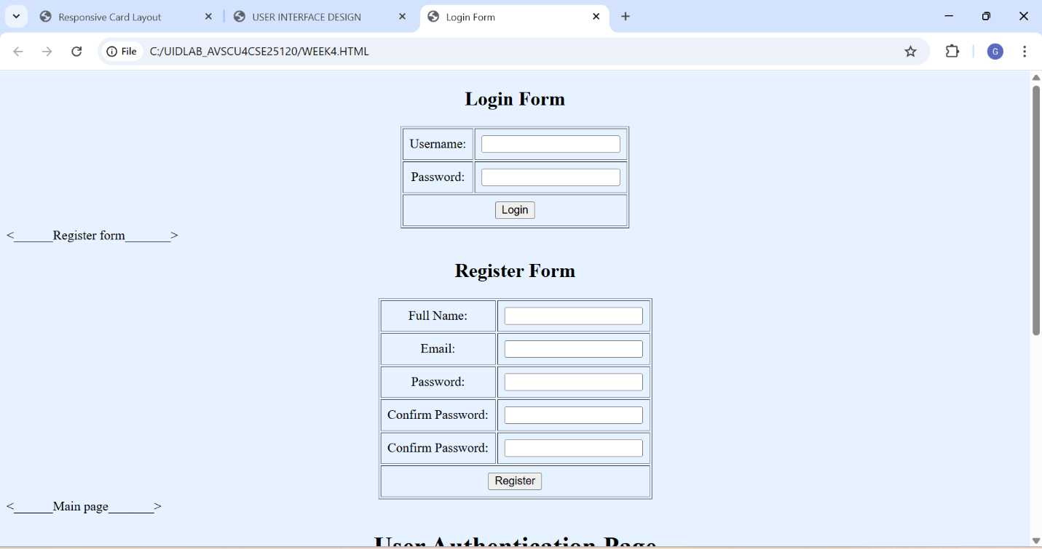

Explanation of the tags: (Inline Frame): Displays another HTML page inside the current page. Two separate pages are created: Login Form and Register Form. A main page uses two iframes to show both forms side by side. src attribute: Specifies which page to load inside the iframe. width & height: Set the iframe size. A table with two columns is used to align the iframes in one row. Each iframe loads a different form page (login / register).

Week-5
1 . Aim : To create a responsive card layout using HTML and CSS with three cards, each containing an image, title, and button.
Procedure:
<!DOCTYPE html>
<html>
<head>
<title>Card Layout with Images</title>

<style>
body{
font-family: Arial, sans-serif;
background-color: #f2f2f2;
}

.container{
display: flex;
justify-content: center;
gap: 20px;
margin-top: 50px;
}

.card{
background-color: white;
width: 260px;
border-radius: 10px;
box-shadow: 0 4px 8px rgba(0,0,0,0.2);
overflow: hidden;
text-align: center;
}

.card img{
width: 100%;
height: 180px;
object-fit: cover;
}

.card h3{
margin: 15px 0 10px 0;
}

.card p{
font-size: 14px;
padding: 0 15px;
color: gray;
}

.card button{
margin: 15px 0 20px 0;
padding: 8px 15px;
border: none;
background-color: #007bff;
color: white;
border-radius: 5px;
cursor: pointer;
}

.card button:hover{
background-color: #0056b3;
}
</style>
</head>

<body>

<div class="container">

<div class="card">
<img src="https://picsum.photos/300/200?1" alt="Image 1">
<h3>Card 1</h3>
<p>This is the first card description.</p>
<button>Read More</button>
</div>

<div class="card">
<img src="https://picsum.photos/300/200?2" alt="Image 2">
<h3>Card 2</h3>
<p>This is the second card description.</p>
<button>Read More</button>
</div>

<div class="card">
<img src="https://picsum.photos/300/200?3" alt="Image 3">
<h3>Card 3</h3>
<p>This is the third card description.</p>
<button>Read More</button>
</div>

</div>

</body>
</html>

OUTPUT:
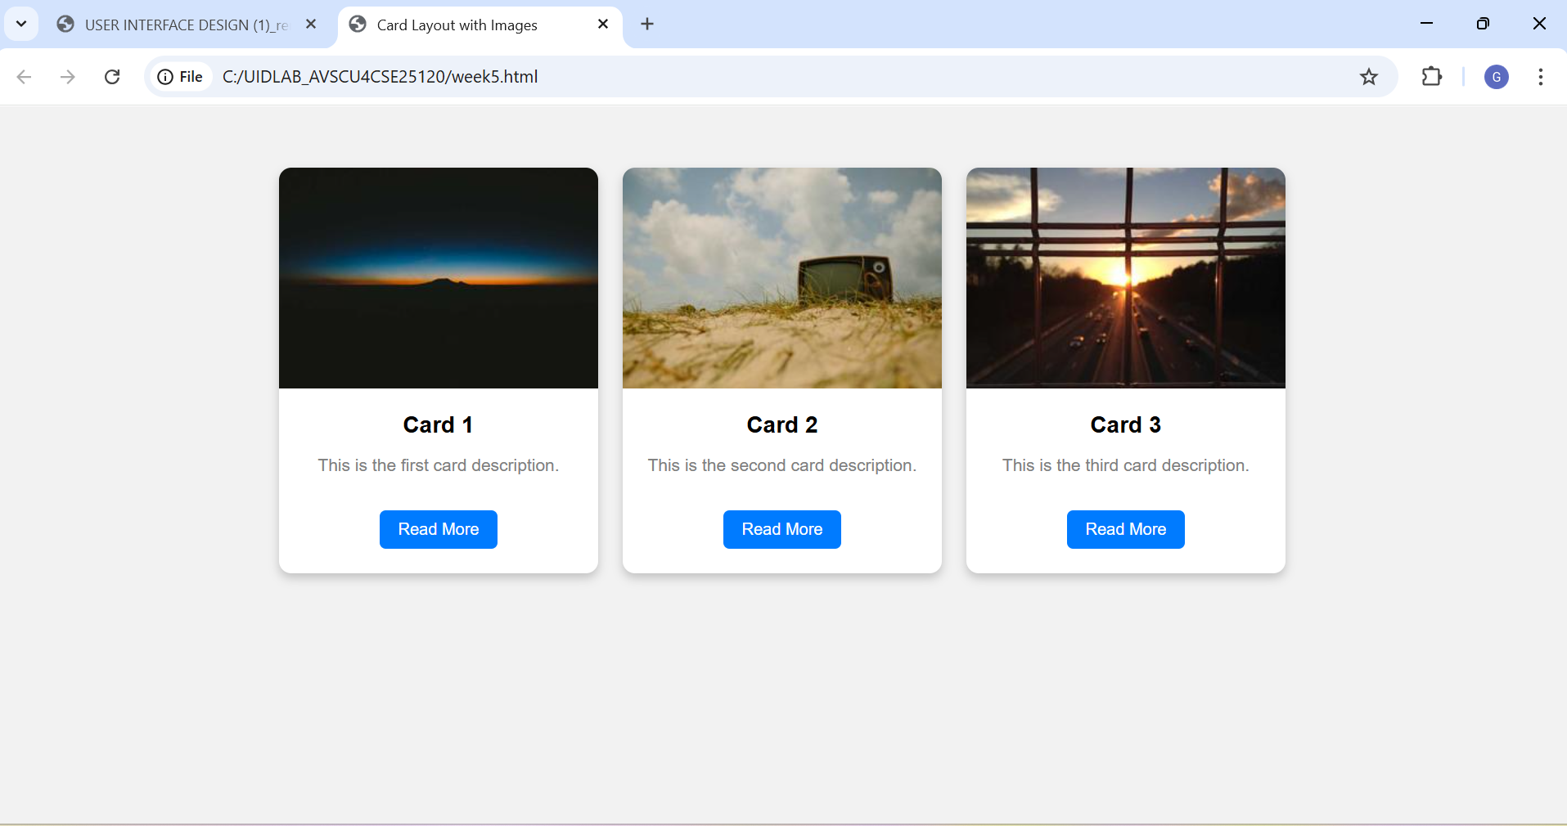
Explanation of the tags:
- flex → Align items in row
- box-shadow → Adds shadow
- border-radius → Rounded corners
- object-fit: cover → Adjust image without distortion
- :hover → Changes style when mouse is over element
- overflow: hidden → Hides extra content outside border
2.Aim: To design a mini website using iframe navigation links (Home, About, Contact), where clicking on each link displays the respective content within the same page using internal or external CSS.
Procedure:
<!DOCTYPE html>
<html>
<body>
<h2>This page contains information about the page.</h2>
</body>
</html>
about.html
<!DOCTYPE html>
<html>
<body>
<h2>if having any issues regarding this</h2>
<p>gayathri@2008gmail.com</p>
<p>phone:1234567890</p>
</body>
</html>
contact.html
<!DOCTYPE html>
<html>
<body>
<h2>This is my Website.Here is the content of this page.</h2>
</body>
</html>
home.html
<!DOCTYPE html>
<html>
<head>
<title> Website with iFrame</title>
<link rel="stylesheet" href="style.css">
</head>
<body>

<header>
<h1>My Mini Website</h1>
</header>

<nav>
<a href="home.html" target="contentFrame">Home</a>
<a href="about.html" target="contentFrame">About</a>
<a href="contact.html" target="contentFrame">Contact</a>
</nav>

<section>
<iframe name="contentFrame" src="home.html"></iframe>
</section>

</body>
</html>
Output:
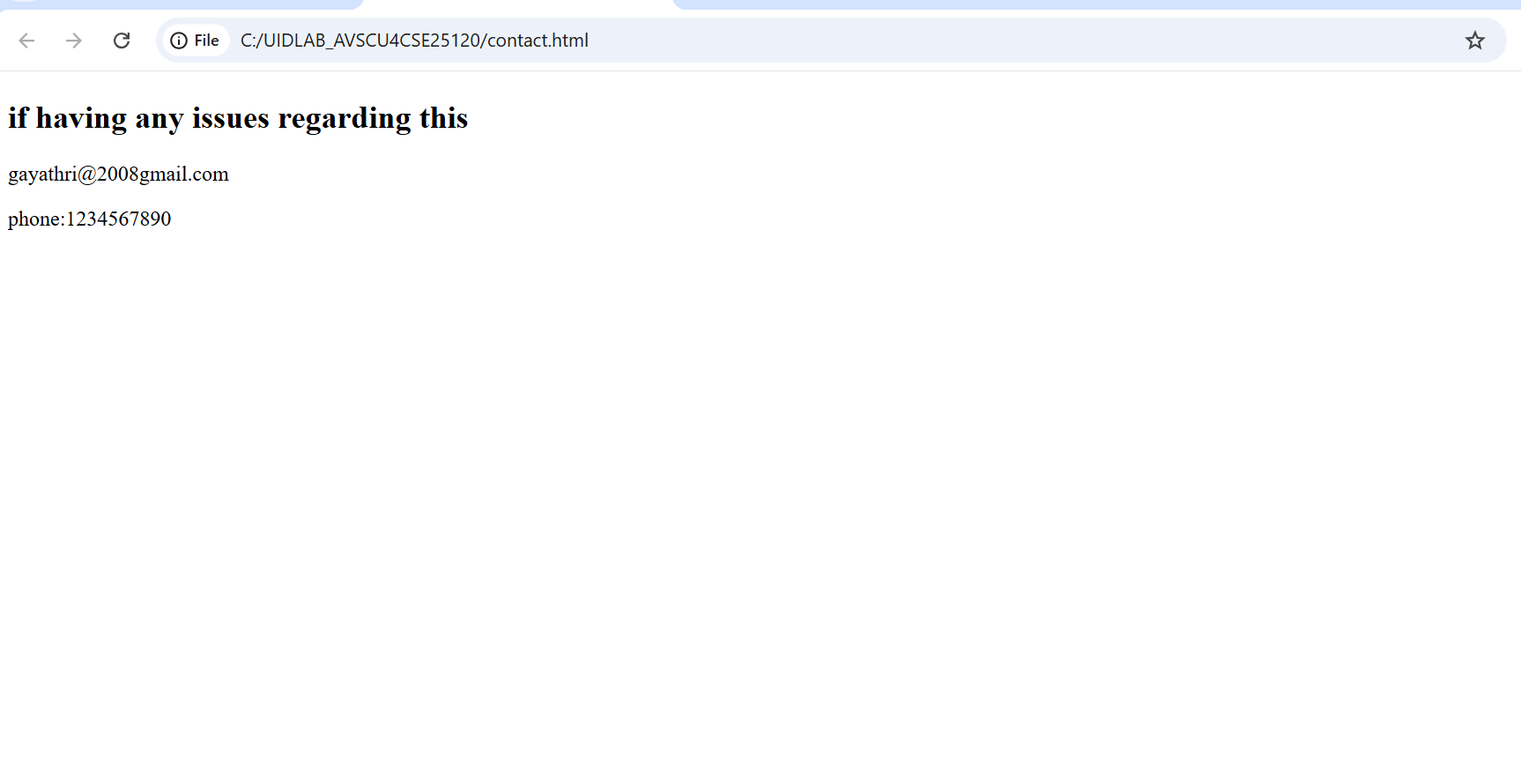

Explanation of tags :
<header>
Used for top section of webpage.
<nav>
Used for navigation links.
<section>
Used to divide content into sections.
<a>
Anchor tag.
Used to create hyperlinks.
Important attributes:
href → Link address
target → Where to open the link
<iframe>
Used to display another webpage inside current webpage.
Important attributes:
src → Page to display
name → Used with targe

EXPLANATION OF THE TAGS :
<header>
- Used for top section of webpage.
<nav>
- Used for navigation links.
<section>
- Used to divide content into sections.
<a>
- Anchor tag.
- Used to create hyperlinks.
- Important attributes: href → Link address target → Where to open the link
<iframe>
- Used to display another webpage inside current webpage.
- Important attributes: src → Page to display name → Used with targe

3.Aim: To design an Amrita login page using HTML and CSS that displays different campuses, where clicking each campus shows its details on the same page
Procedure:
<!DOCTYPE html>
<html>
<head>
<title>Amrita Login Page</title>
<style>
body {
margin: 0;
font-family: Arial, sans-serif;
background: linear-gradient(to right,light orange, pale pink);
background: url(https://wallpapers.com/images/hd/cool-light-blue-l6csxyf32ij7t1or.jpg) no-repeat center center/cover
}
/* Header */
.header {
background-color:lightcoral;
color: white;
text-align: center;
padding: 15px;
font-size: 28px;
font-weight: bold; }
/* Navigation */
.nav {
background-color:darkcyan;
text-align: center;
padding: 10px; }
.nav button {
background: transparent;
border: none;
color:lightgoldenrodyellow;
font-size: 16px;
margin: 0 15px;
cursor: pointer; }
.nav button:hover {
text-decoration: underline; }
/* Main Layout */
.container {
display: flex;
justify-content: center;
align-items: flex-start;
margin: 40px;
gap: 40px; }
/* Login Box */
.login-box {
background: linear-gradient(to bottom,darkviolet,lightcoral);
padding: 25px;
width: 300px;
border-radius: 10px;
color:darkcyan; }
.login-box h2 {
text-align: center; }
.login-box input {
width: 100%;
padding: 8px;
margin: 10px 0;
border: none;
border-radius: 4px;}
.login-box button {
width: 100%;
padding: 8px;
background-color:darkseagreen;
color:light turquoise;
border: none;
border-radius: 4px;
cursor: pointer;}
/* Campus Details */
.campus-details {
background:palegoldenrod;
width: 500px;
padding: 20px;
border-radius: 10px; }
.campus-details img {
width: 100%;
height: 200px;
object-fit: cover;
margin-top: 10px; }
</style>
</head>
<body>
<div class="header">
AMRITA VISHWA VIDHYAPEETAM
</div>
<div class="nav">
<button onclick="showCampus('coimbatore')">Coimbatore</button>
<button onclick="showCampus('amritapuri')">Amritapuri</button>
<button onclick="showCampus('bangalore')">Bangalore</button>
<button onclick="showCampus('chennai')">Chennai</button>
<button onclick="showCampus('Amaravathi')">Amaravathi</button>
</div>
<div class="container">
<!-- Login Section -->
<div class="login-box">
<h2>Login</h2>
<input type="text" placeholder="Email">
<input type="password" placeholder="Password">
<button>Login</button>
</div>
<!-- Campus Info Section -->
<div class="campus-details" id="campusInfo">
<h2>About the Campus</h2>
<p>Select a campus from above to view details.</p>
</div>
<script>
function showCampus(campus) {
let info = document.getElementById("campusInfo");
if (campus === "coimbatore") {
info.innerHTML = `
<h2>Coimbatore Campus</h2>
<p>Located in Tamil Nadu. Known for Engineering and Technology programs with modern infrastructure.</p>
<img src="https://tse3.mm.bing.net/th/id/OIP.elkN6U_aVSlLuBTcPX2q_QHaEK?pid=Api&P=0&h=180"
alt="Coimbatore Campus"> `; }
else if (campus === "amritapuri") {
info.innerHTML = `
<h2>Amritapuri Campus</h2>
<p>Located in Kerala. Famous for Arts, Science and research activities in a peaceful environment.</p>
<img src="https://tse4.mm.bing.net/th/id/OIP.jPuLxk4ALi6yUzvKevF7fgHaEM?pid=Api&P=0&h=180" alt="Amritapuri
Campus"> `;}
else if (campus === "bangalore") {
info.innerHTML = `
<h2>Bangalore Campus</h2>
<p>Located in Karnataka. Offers Engineering and Management programs with industry exposure.</p>
<img src="https://tse4.mm.bing.net/th/id/OIP.AxDXEuEdONmn1Poym0qaiQHaDt?pid=Api&P=0&h=180"
alt="Bangalore Campus">`; }
else if (campus === "chennai") {
info.innerHTML = `
<h2>Chennai Campus</h2>
<p>Located in Tamil Nadu. Special focus on engineering disciplines and innovation.</p>
<img src="https://tse2.mm.bing.net/th/id/OIP.5Cd4ekgT1P_EX7zhzH_D1AHaDp?pid=Api&P=0&h=180"
alt="Chennai Campus">
`;
}
else if (campus === "Amaravathi") {
info.innerHTML = `
<h2>Amaravathi Campus</h2>
<p>Located in Mangalagiri. Famous for Arts, Science and research activities in a peaceful environment.</p>
<img src="https://tse4.mm.bing.net/th/id/OIP.WIKj0_HGLKy7-vepQuwuLwHaDK?pid=Api&P=0&h=180"
alt="Amaravathi Campus">;}}
</script>
</body>
</html>

Output:
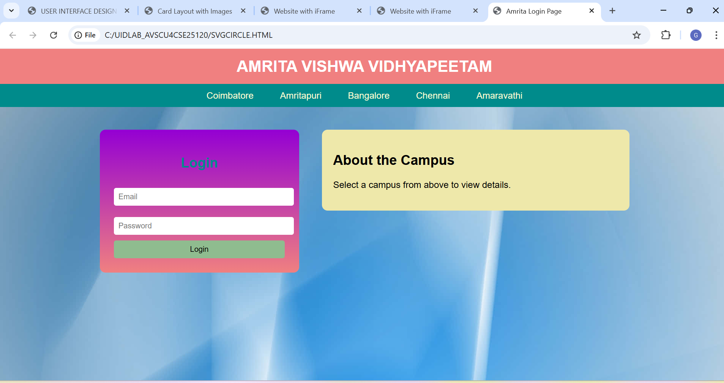

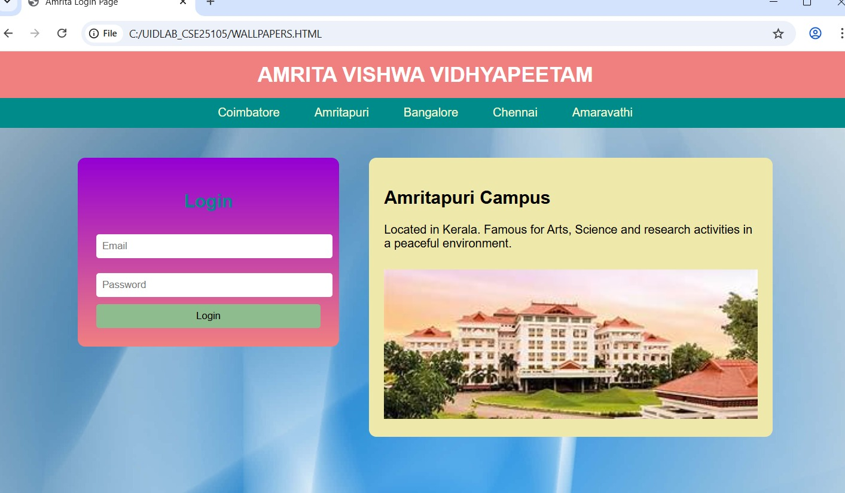

Explanation of the tags:
CSS Styling
🔹 body Sets background image.
Removes margin.
Applies font style.
🔹 .header
Top banner.
Background color: lightcoral.
Center aligned white text.
🔹 .nav
Navigation bar.
Contains buttons for campuses.
🔹 .container
Uses display: flex;
Aligns login box and campus details side by side.
🔹 .login-box
Styled login form.
Gradient background.
Rounded corners.
🔹 .campus-details
Displays campus information.
Contains heading, paragraph and image.
Navigation Buttons
Coimbatore
onclick calls JavaScript function.
Sends campus name as parameter.
Week 6
1. <!DOCTYPE html>
<html>
<head>
<title>gayathri Shopping</title>

<style>
body{
margin:0;
font-family:Arial, Helvetica, sans-serif;
background:lightyellow;
}

.header{
background:lightcoral;
color:white;
text-align:center;
padding:15px;
font-size:22px;
}

.sale{
background:lemonchiffon;
text-align:center;
padding:10px;
font-weight:bold;
}

.container{
display:flex;
padding:8px;
}

.sidebar{
width:200px;
background:mistyrose;
padding:10px;
border-radius:8px;
}

.sidebar button{
width:100%;
padding:8px;
margin:4px 0;
border:none;
background:lightpink;
cursor:pointer;
}

.products{
flex:1;
display:grid;
grid-template-columns:repeat(3,1fr); /* 3 items per row */
gap:10px; /* reduced gap */
padding:5px;
}

.card{
background:lightgoldenrodyellow;
padding:10px;
text-align:center;
border-radius:6px;
}

.card img{
width:100%;
height:120px; /* smaller height */
object-fit:cover;
}

.price{
color:indianred;
font-weight:bold;
}

.card button{
background:salmon;
color:white;
border:none;
padding:6px 12px;
margin-top:6px;
cursor:pointer;
}

.footer{
background:salmon;
color:white;
text-align:center;
padding:10px;
margin-top:8px;
}
</style>

<script>
function showCategory(category){
let products=document.querySelectorAll(".card");
products.forEach(function(product){
if(category=="all"){
product.style.display="block";
}
else if(product.classList.contains(category)){
product.style.display="block";
}
else{
product.style.display="none";
}
});
}
</script>
</head>

<body>

<div class="header">
Hasinishekhar SPA Shopping
</div>

<div class="sale">
Ugadi Special Sale – Up to 70% Off
</div>

<div class="container">

<div class="sidebar">
<h3>Categories</h3>
<button onclick="showCategory('viewitems')">View Items</button>
<button onclick="showCategory('furniture')">Furniture</button>
<button onclick="showCategory('clothing')">Clothing</button>
<button onclick="showCategory('appliances')">Home Appliances</button>
<button onclick="showCategory('stationary')">Stationary</button>
<button onclick="showCategory('groceries')">Groceries</button>
<button onclick="showCategory('beauty')">Beauty Products</button>
<button onclick="showCategory('all')">Show All</button>
</div>

<div class="products">

<!-- View Items (first category, highlights) -->
<div class="card viewitems">
<img src="sofa2.html">
<h3>Furniture</h3>
<p class="price">55000/-</p>
<button>Add to Cart</button>
</div>

<div class="card viewitems">
<img src="t shirt .html">
<h3>Clothing</h3>
<p class="price">700/-</p>
<button>Add to Cart</button>
</div>

<div class="card viewitems">
<img src="washing machine.html">
<h3>Appliances</h3>
<p class="price">12000/-</p>
<button>Add to Cart</button>
</div>

<div class="card viewitems">
<img src="stationary.html">
<h3>Stationary</h3>
<p class="price">120/-</p>
<button>Add to Cart</button>
</div>

<div class="card viewitems">
<img src="vegitables.html">
<h3>Groceries</h3>
<p class="price">180/-</p>
<button>Add to Cart</button>
</div>

<div class="card viewitems">
<img src="https://images.unsplash.com/photo-1522335789203-aabd1fc54bc9">
<h3>Beauty</h3>
<p class="price">800/-</p>
<button>Add to Cart</button>
</div>

<!-- Furniture -->
<div class="card furniture">
<img src="sofa2.html">
<h3>Sofa Set</h3>
<p class="price">55000/-</p>
<button>Add to Cart</button>
</div>

<div class="card furniture">
<img src="bed.html">
<h3>Wooden Bed</h3>
<p class="price">30000/-</p>
<button>Add to Cart</button>
</div>

<div class="card furniture">
<img src="table.html">
<h3>Dining Table</h3>
<p class="price">15000/-</p>
<button>Add to Cart</button>
</div>

<div class="card furniture">
<img src="chair.html">
<h3>Wooden Chair</h3>
<p class="price">5000/-</p>
<button>Add to Cart</button>
</div>

<!-- Clothing -->
<div class="card clothing">
<img src="t shirt .html">
<h3>T-Shirt</h3>
<p class="price">700/-</p>
<button>Add to Cart</button>
</div>

<div class="card clothing">
<img src="jackets2.html">
<h3>Jacket</h3>
<p class="price">1200/-</p>
<button>Add to Cart</button>
</div>

<div class="card clothing">
<img src="jeans.html">
<h3>Jeans</h3>
<p class="price">1500/-</p>
<button>Add to Cart</button>
</div>

<div class="card clothing">
<img src="dress.html">
<h3>Dress</h3>
<p class="price">2000/-</p>
<button>Add to Cart</button>
</div>

<!-- Appliances -->
<div class="card appliances">
<img src="washing machine.html">
<h3>Washing Machine</h3>
<p class="price">12000/-</p>
<button>Add to Cart</button>
</div>

<div class="card appliances">
<img src="refrigerator.html">
<h3>Refrigerator</h3>
<p class="price">15000/-</p>
<button>Add to Cart</button>
</div>

<div class="card appliances">
<img src="microwave2.html">
<h3>Microwave</h3>
<p class="price">8000/-</p>
<button>Add to Cart</button>
</div>

<div class="card appliances">
<img src="ac.html">
<h3>Air Conditioner</h3>
<p class="price">35000/-</p>
<button>Add to Cart</button>
</div>

<!-- Stationary -->
<div class="card stationary">
<img src="book.html">
<h3>Notebook</h3>
<p class="price">120/-</p>
<button>Add to Cart</button>
</div>

<div class="card stationary">
<img src="pens.html">
<h3>Pens</h3>
<p class="price">80/-</p>
<button>Add to Cart</button>
</div>

<div class="card stationary">
<img src="kit.html">
<h3>School Kit</h3>
<p class="price">250/-</p>
<button>Add to Cart</button>
</div>

<div class="card stationary">
<img src="files.html">
<h3>Office Supplies</h3>
<p class="price">300/-</p>
<button>Add to Cart</button>
</div>

<!-- Groceries -->
<div class="card groceries">
<img src="vegitables.html">
<h3>Vegetables</h3>
<p class="price">200/-</p>
<button>Add to Cart</button>
</div>

<div class="card groceries">
<img src="fruits.html">
<h3>Fruits</h3>
<p class="price">180/-</p>
<button>Add to Cart</button>
</div>

<div class="card groceries">
<img src="food.html">
<h3>Food Pack</h3>
<p class="price">350/-</p>
<button>Add to Cart</button>
</div>

<div class="card groceries">
<img src="organic.html">
<h3>Organic Groceries</h3>
<p class="price">400/-</p>
<button>Add to Cart</button>
</div>

<!-- Beauty -->
<div class="card beauty">
<img src="makeup.html">
<h3>Makeup Kit</h3>
<p class="price">1600/-</p>
<button>Add to Cart</button>
</div>

<div class="card beauty">
<img src="lipstick.html">
<h3>Lipsticks</h3>
<p class="price">800/-</p>
<button>Add to Cart</button>
</div>
Output :
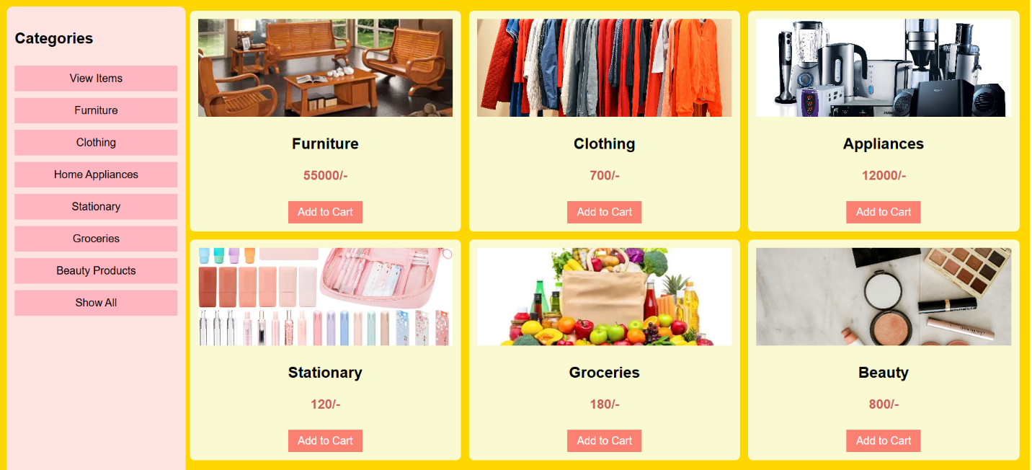
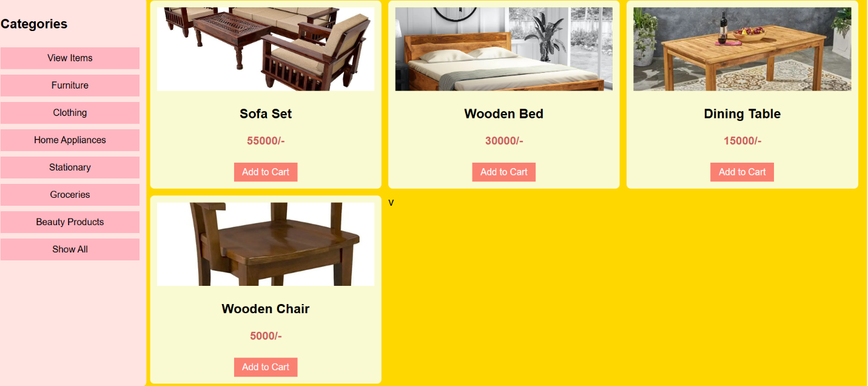

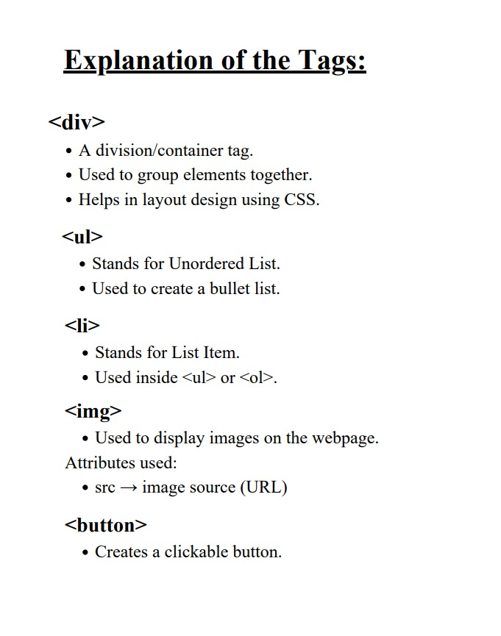

Week 7:
Aim: Steps to install GitHub
Procedure:
Step-1:
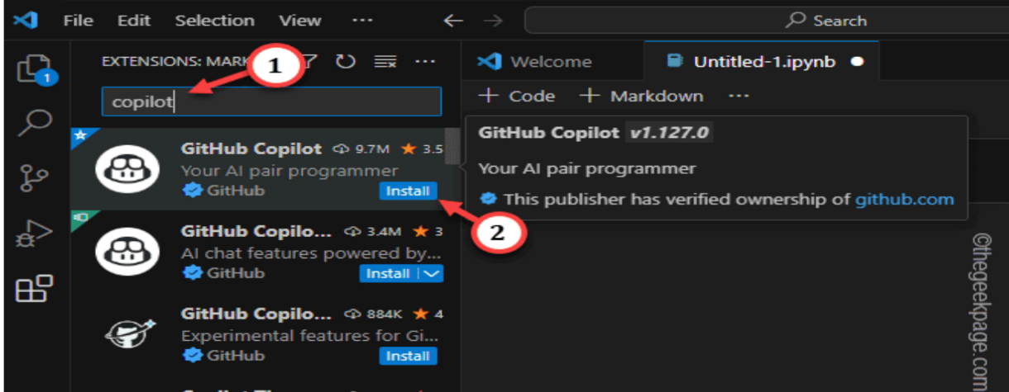

Step 2:
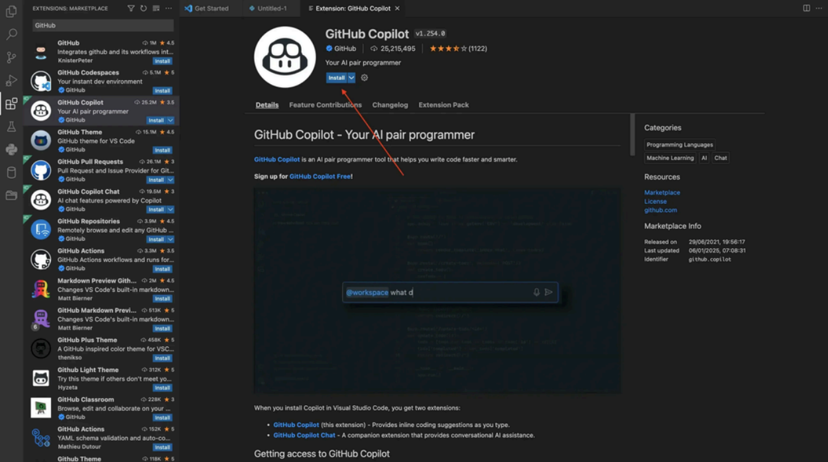
Step 3:

Step 4:
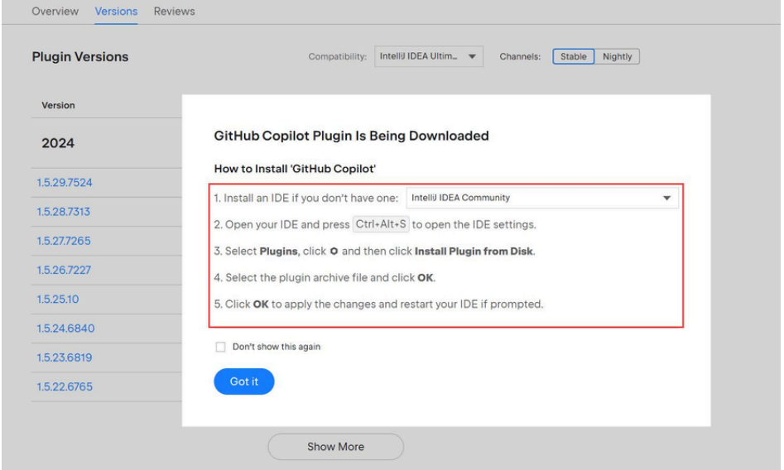

Step 5:
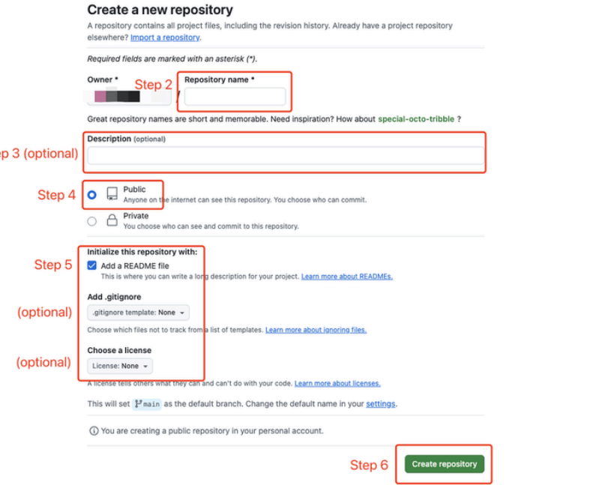
Step 6:
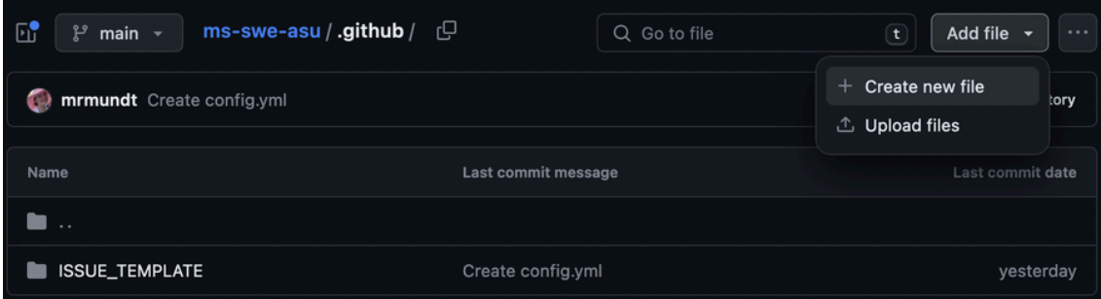

Week-8
- .Create a webpage that displays a square that continuously rotates 360° using CSS animation.
Procedure:
Code:
<!DOCTYPE html>
<html lang="en">
<head>
<meta charset="UTF-8">
<title>Rotating Square</title>

<style>
body {
margin: 0;
height: 100vh;
display: flex;
justify-content: center;
align-items: center;
background-color: #111;
}

.square {
width: 150px;
height: 150px;
background-color: #4CAF50;
animation: rotateSquare 2s linear infinite;
}

@keyframes rotateSquare {
from {
transform: rotate(0deg);
}
to {
transform: rotate(360deg);
}
}
</style>

</head>
<body>

<div class="square"></div>

</body>
</html>

Output :
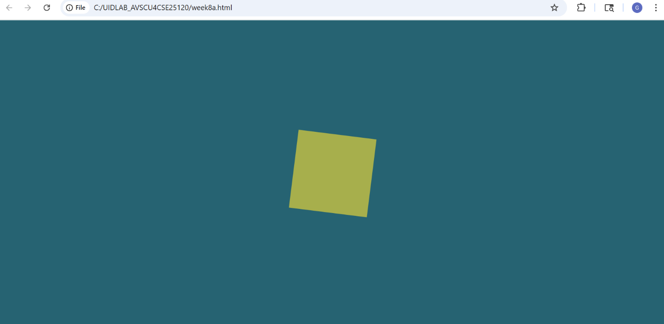

Explanation of tags:
* <!DOCTYPE html> → Defines the document as HTML5.
* <html> → Root element that contains the whole webpage.
* <head> → Holds metadata and styling (not visible on page).
* <meta> → Specifies character encoding (UTF-8).
* <title> → Sets the browser tab name.
* <style> → Contains internal CSS for styling the page.
* <body> → Contains all visible content of the webpage.
* <div> → Generic container used to group and style elements.

- Create a ball that moves up and down continuously only using CSS animations
Procedure:
Code:
<!DOCTYPE html>
<html lang="en">
<head>
<meta charset="UTF-8">
<title>Bouncing Ball</title>

<style>
body {
margin: 0;
height: 100vh;
display: flex;
justify-content: center;
align-items: center;
background-color: #111;
}

.ball {
width: 80px;
height: 80px;
background-color: #ff4757;
border-radius: 50%;
animation: bounce 1s ease-in-out infinite alternate;
}

@keyframes bounce {
from {
transform: translateY(0);
}
to {
transform: translateY(-200px);
}
}
</style>

</head>
<body>

<div class="ball"></div>

</body>
</html>

Output:
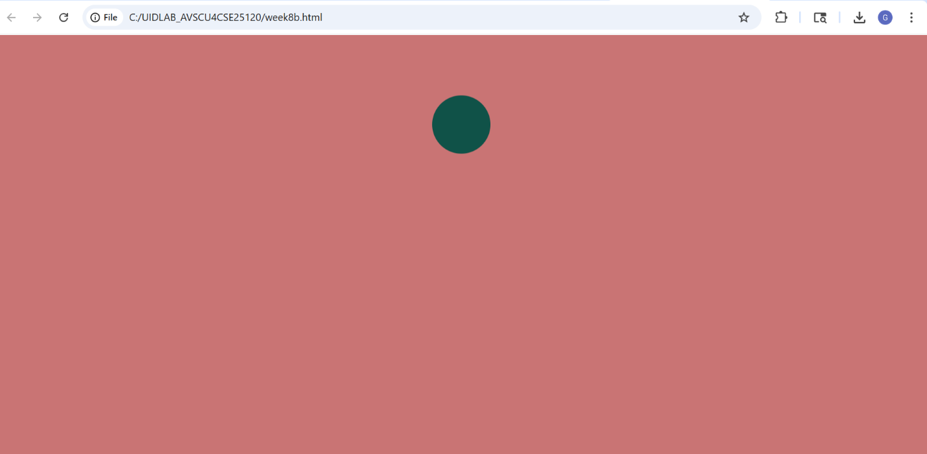
Explanation of tags:
* <!DOCTYPE html> → Declares the document type as HTML5.
* <html lang="en"> → Root element of the webpage, with language set to English.
* <head> → Contains meta information and settings for the webpage.
* <meta charset="UTF-8"> → Sets character encoding to support all text symbols.
* <title> → Defines the title shown in the browser tab.
* <style> → Contains internal CSS styling for the page.
* <body> → Holds all visible content displayed on the webpage.
* <div class="ball"> → Creates a container element styled as a bouncing ball.

- Create a circle that moves horizontally and rotates at the same time.
Procedure:
Code:
<!DOCTYPE html>
<html lang="en">
<head>
<meta charset="UTF-8">
<title>Moving & Rotating Circle</title>

<style>
body {
margin: 0;
height: 100vh;
display: flex;
align-items: center;
background-color: #111;
overflow: hidden;
}

.circle {
width: 80px;
height: 80px;
background-color: #1e90ff;
border-radius: 50%;
position: relative;
animation: moveRotate 3s linear infinite;
}

@keyframes moveRotate {
0% {
transform: translateX(0) rotate(0deg);
}
100% {
transform: translateX(300px) rotate(360deg);
}
}
</style>

</head>
<body>

<div class="circle"></div>

</body>
</html>

Output:
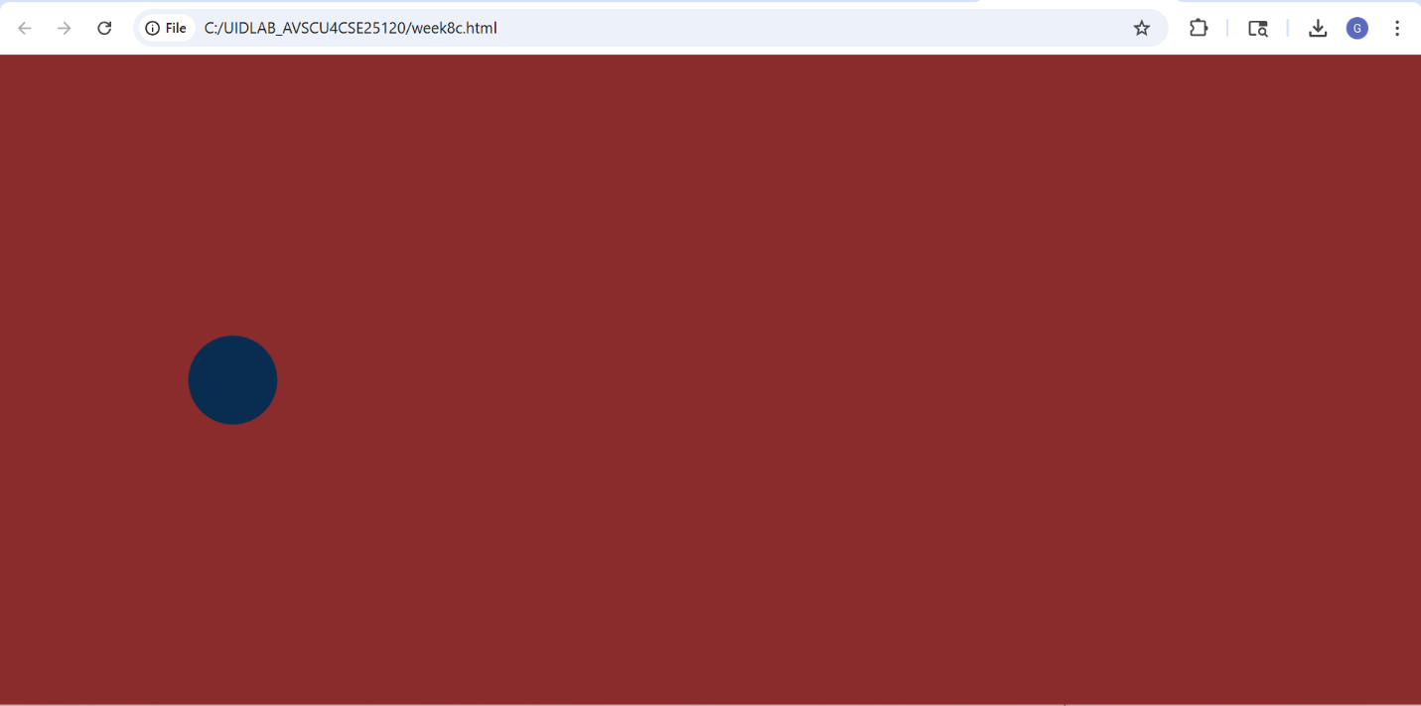
Explanation of tags :
* <!DOCTYPE html> → Defines the document as HTML5.
* <html lang="en"> → Root element of the page with English language setting.
* <head> → Contains metadata and styling information.
* <meta charset="UTF-8"> → Ensures proper display of all characters.
* <title> → Sets the browser tab title.
* <style> → Holds the CSS used to design and animate elements.
* <body> → Contains the visible content of the webpage.

Week-9:
Create an webpage using html, CSS, java script based on the given conditions:
a)Create a button for each program, based on the button clicked the corresponding program has to be executed and should display the output.
b)The logics for each button includes finding an even numbers, odd number, prime or not, factorial of a number, amstrong or not.
c)Use appropriate designs to display the output.
Code :
<!DOCTYPE html>
<html lang="en">
<head>
<meta charset="UTF-8">
<title>Number Logic Programs</title>

<style>
body {
font-family: Arial, sans-serif;
background: linear-gradient(to right, #a81c7e, #00f2fe);
text-align: center;
padding: 40px;
color: #333;
}

h1 {
color: white;
margin-bottom: 30px;
}

.container {
background: white;
padding: 30px;
border-radius: 15px;
width: 350px;
margin: auto;
box-shadow: 0 10px 25px rgba(0,0,0,0.2);
}

input {
padding: 10px;
width: 80%;
margin-bottom: 20px;
border-radius: 8px;
border: 1px solid #7d7070;
font-size: 16px;
}

.buttons button {
margin: 5px;
padding: 10px 15px;
border: none;
border-radius: 8px;
background-color: #ba3589;
color: rgb(211, 189, 200);
font-size: 14px;
cursor: pointer;
transition: 0.3s;
}

.buttons button:hover {
background-color: #ab227f;
transform: scale(1.05);
}

.output {
margin-top: 20px;
padding: 15px;
background-color: #c9bdbd;
border-radius: 10px;
font-weight: bold;
min-height: 40px;
}
</style>
</head>

<body>

<h1>Number Logic Programs</h1>

<div class="container">
<input type="number" id="num" placeholder="Enter a number">

<div class="buttons">
<button onclick="checkEven()">Even</button>
<button onclick="checkOdd()">Odd</button>
<button onclick="checkPrime()">Prime</button>
<button onclick="factorial()">Factorial</button>
<button onclick="checkArmstrong()">Armstrong</button>
</div>

<div class="output" id="result">Output will appear here</div>
</div>

<script>

function getNumber() {
let num = document.getElementById("num").value;
if (num === "") {
alert("Please enter a number");
return null;
}
return parseInt(num);
}

// Even
function checkEven() {
let num = getNumber();
if (num === null) return;

let result = (num % 2 === 0) ? "Even Number" : "Not an Even Number";
display(result);
}

// Odd
function checkOdd() {
let num = getNumber();
if (num === null) return;

let result = (num % 2 !== 0) ? "Odd Number" : "Not an Odd Number";
display(result);
}

// Prime
function checkPrime() {
let num = getNumber();
if (num === null) return;

if (num <= 1) {
display("Not a Prime Number");
return;
}

for (let i = 2; i <= Math.sqrt(num); i++) {
if (num % i === 0) {
display("Not a Prime Number");
return;
}
}

display("Prime Number");
}

// Factorial
function factorial() {
let num = getNumber();
if (num === null) return;

let fact = 1;
for (let i = 1; i <= num; i++) {
fact *= i;
}

display("Factorial: " + fact);
}

// Armstrong
function checkArmstrong() {
let num = getNumber();
if (num === null) return;

let temp = num;
let sum = 0;
let digits = num.toString().length;

while (temp > 0) {
let rem = temp % 10;
sum += Math.pow(rem, digits);
temp = Math.floor(temp / 10);
}

if (sum === num) {
display("Armstrong Number");
} else {
display("Not an Armstrong Number");
}
}

// Display output
function display(msg) {
document.getElementById("result").innerText = msg;
}

</script>

</body>
</html>

Output: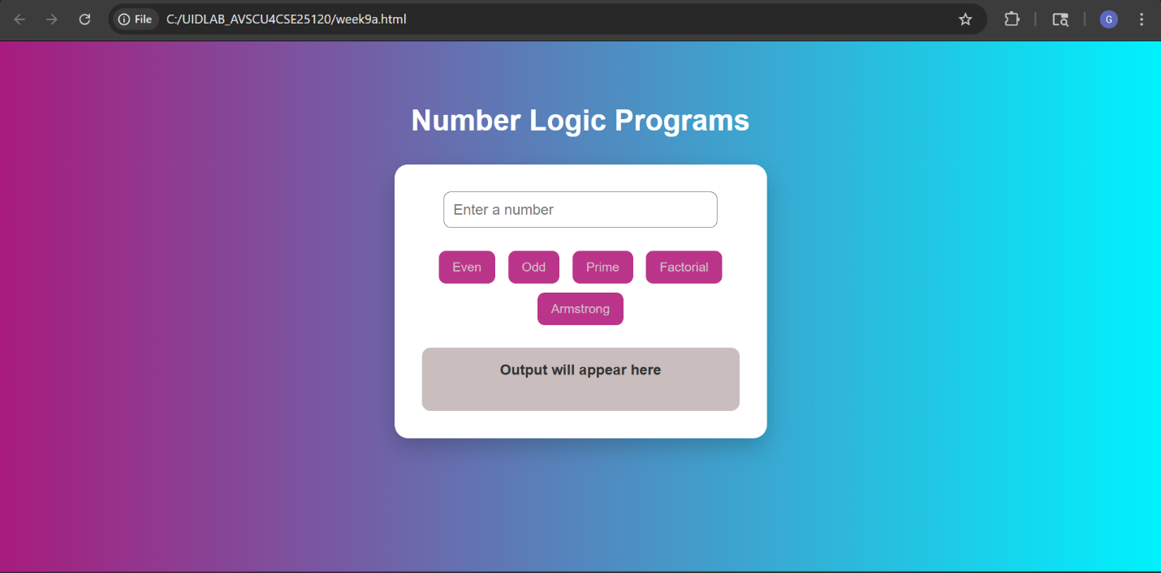
Explanation of tags :
1.<div class=”grid”>
Holds all the boxes
Helps arrange them nicely using CSS grid
2.Grid Layout
• Creates responsive layout
• Boxes adjust automatically based on screen
3.Box Design
Makes each block look like a card
- Buttons
• Changes color when mouse hovers
JavaScript :
- Even Number
function checkEven() {
let num = document.getElementById("evenNum").value;
let result = (num % 2 == 0) ? "Even Number" : "Not Even"; document.getElementById("evenOut").innerText = result;
}
• Gets input value
• % 2 == 0 → checks even
• Displays result
- Odd Number
(num % 2 != 0)
• If remainder ≠ 0 → odd number
- Prime Number
for (let i = 2; i < num; i++) {
if (num % i == 0) {
flag = false ;
}
}
• Prime → divisible only by 1 and itself
• Loop checks divisibility
• If divisible → NOT prime
4.Factorial
for (let i = 1; i <= num; i++) {
fact *= i;
}
5! = 5 × 4 × 3 × 2 × 1 = 120
5. Armstrong Number
while (temp > 0) {
let digit = temp % 10;
sum += Math.pow(digit, digits);
}
• Count digits
• Raise each digit to power of total digits
• Add them
Example:
153 → 1³ + 5³ + 3³ = 153

Week 10 :
- Write a Javascript conditional statement to find thesign of product of three numbers using functions.Display an alert box with specified sign.

Code:
<!DOCTYPE html>
<html>
<head>
<title>Sign of Product</title>
</head>

<body>

<h2>Find Sign of Product of 3 Numbers</h2>

<!-- Input boxes -->
<input type="number" id="num1" placeholder="Enter first number"><br><br>
<input type="number" id="num2" placeholder="Enter second number"><br><br>
<input type="number" id="num3" placeholder="Enter third number"><br><br>

<!-- Button -->
<button onclick="findSign()">Check Sign</button>

<script>
function findSign() {
let a = parseInt(document.getElementById("num1").value);
let b = parseInt(document.getElementById("num2").value);
let c = parseInt(document.getElementById("num3").value);

let product = a * b * c;

if (product > 0) {
alert("The sign is plus");
} else if (product < 0) {
alert("The sign is minus");
} else {
alert("The product is zero");
}
}
</Script>
</body>
</html>
Output :
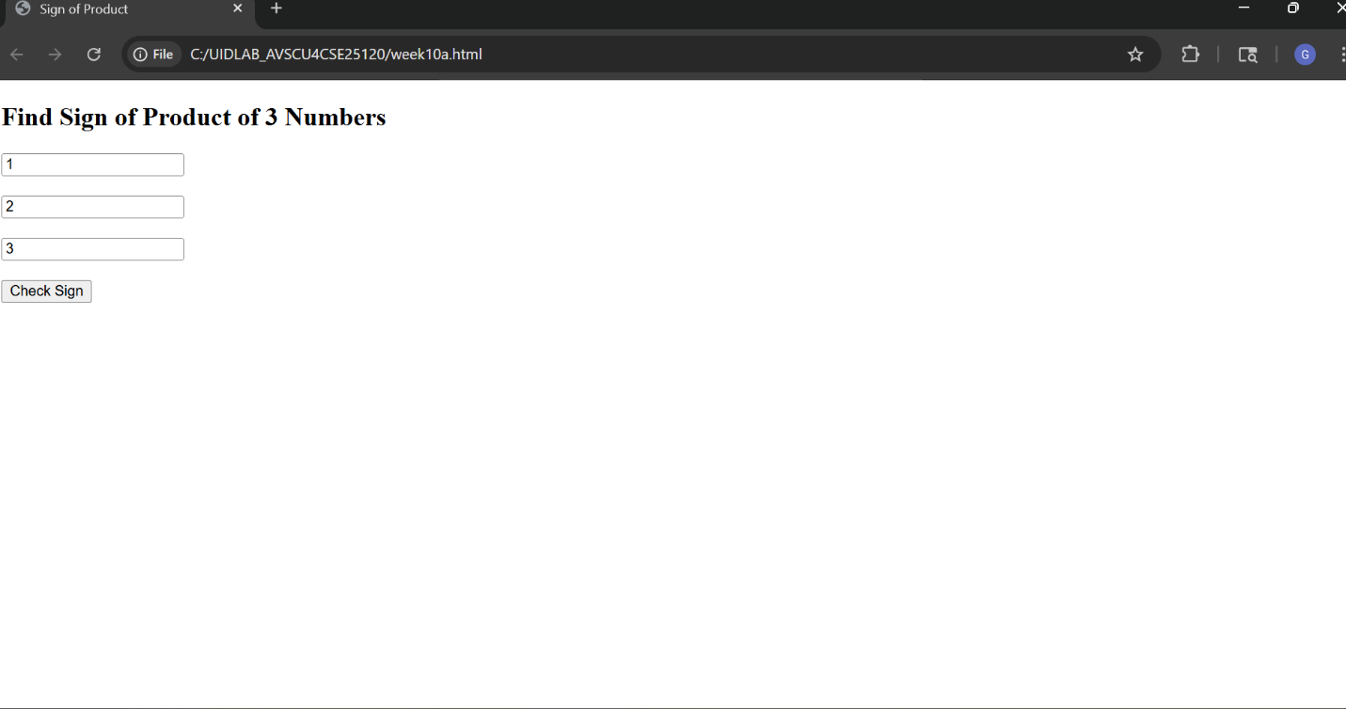
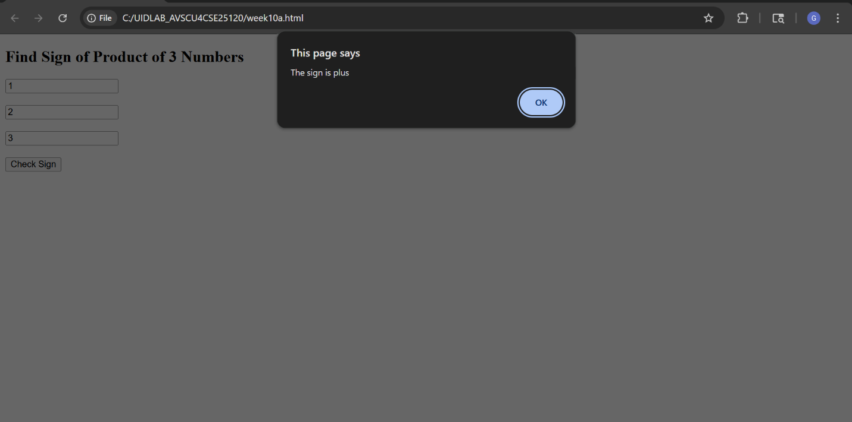
Explanation of tags :
1.Function
This creates a function named findSign
It runs when button is clicked:
2.document
Represents the whole webpage
3.getElementById("num1")
Selects the input box with id "num1"
4.value
Gets what user typed
5.Number(...)
Converts input (string) → number
Without Number(), it treats input like text
6.Product Calculation
Multiplies 3 numbers
7. Selecting Elements for Output
These are your custom alert components
overlay → full screen background
alertBox → message box

8. Conditional Statements
if (product > 0)
Checks if product is positive

else
if (product < 0) Checks if negative
else
If not positive or negative → must be zero
9. Changing Content
Changes text inside alert box
10. Changing Style Dynamically
This applies CSS classes
• alertBox → basic style
• positive → green color
11. Showing the Popup
Makes popup visible
12. Auto Hide
• setTimeout() → runs code after delay
• 2000 → 2 seconds
After 2 sec → popup disappears

10(B)Aim:Write a Javascript conditional statement to sort three numbers using functions.Display an alert box to show the result.
Procedure:
<!DOCTYPE html>
<html>
<head>
<title>Sort Three Numbers</title>
<!k.gayathri AV.SC.U4CSE25120.!
<style>
body {
font-family: Arial, sans-serif;
119
background: linear-gradient(135deg, #d1f394, #def965);
height: 100vh;
display: flex;
justify-content: center;
align-items: center;
margin: 0;
}
.box {
background: rgb(225, 179, 179);
padding: 30px;
width: 320px;
border-radius: 15px;
box-shadow: 0 10px 25px rgba(0,0,0,0.2);
text-align: center;
}
input {
width: 90%;
padding: 10px;
margin: 10px 0;
border-radius: 8px;
border: 1px solid #ccc;
}
button {
padding: 10px 20px;
background: linear-gradient(135deg, #b2badf, #c5cdab);
color: white;
border: none;
border-radius: 8px;
cursor: pointer;
}
/* Overlay */
.overlay {
display: none;
position: fixed;
top: 0;
left: 0;
width: 100%;
height: 100%;
background: rgba(0,0,0,0.6);
}
/* Alert box */
.alertBox {
position: absolute;
top: 40%;
left: 50%;
transform: translate(-50%, -50%);
background: #333;
color: white;
padding: 20px 30px;
border-radius: 12px;
font-size: 18px;
}
</style>
</head>
<body>
<div class="box">
<h2>Sort 3 Numbers</h2>
<input type="number" id="num1" placeholder="First number"><br>
<input type="number" id="num2" placeholder="Second number"><br>
<input type="number" id="num3" placeholder="Third number"><br>
<button onclick="sortNumbers()">Sort</button>
</div>
<!-- Overlay -->
<div id="overlay" class="overlay">
<div id="alertBox" class="alertBox"></div>
</div>
<script>
function sortNumbers() {
let a = Number(document.getElementById("num1").value);
let b = Number(document.getElementById("num2").value);
let c = Number(document.getElementById("num3").value);
let overlay = document.getElementById("overlay");
let alertBox = document.getElementById("alertBox");
let result;
// Sorting logic using condition
if (a <= b && a <= c) {
if (b <= c) {
result = a + ", " + b + ", " + c;
} else {
result = a + ", " + c + ", " + b;
}
}
else if (b <= a && b <= c) {
if (a <= c) {
result = b + ", " + a + ", " + c;
} else {
result = b + ", " + c + ", " + a;
}
}
else {
if (a <= b) {
result = c + ", " + a + ", " + b;
} else {
result = c + ", " + b + ", " + a;
}
}
alertBox.innerText = "Sorted order: " + result;
overlay.style.display = "block";
setTimeout(() => {
overlay.style.display = "none";
}, 2500);
}
</script>
</body>
</html>
Output :
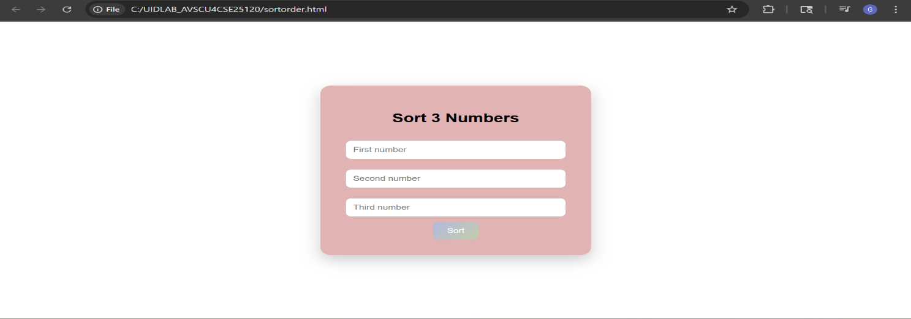
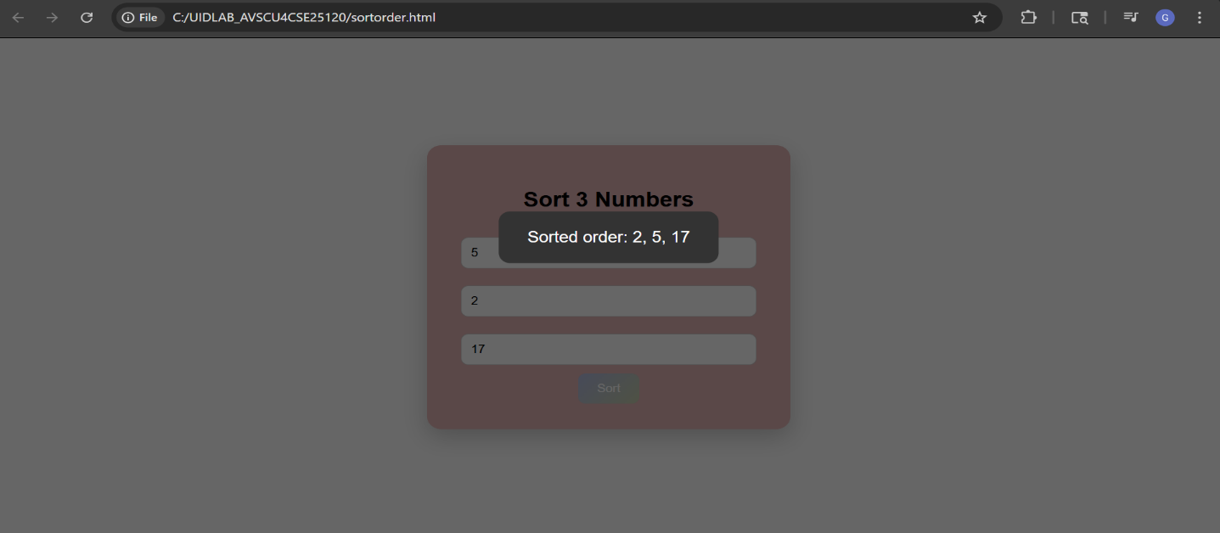
Explanation:
- Function
This defines a function
It runs when button is clicked:
- Taking Input from User
• document → represents webpage
• getElementById() → selects input field
• .value → gets user input
• Number() → converts string → number
- Accessing Alert Elements Used for custom popup:
• overlay → background screen
• alertBox → message box
- Variable to Store Result
Stores sorted numbers as a string
5. Main Sorting Logic
Step 1: Find smallest number
• a is smallest
Step2: Compare remaining two
if (b <= c)
Then order:
a, b, c
Else:
a, c, b
Second Case:
else if (b <= a && b <= c)
b is smallest
Then compare a and c
Final Case:
Else
c is smallest
6.Storing Result
Converts numbers → string format
7. Displaying Result
Shows output inside custom alert
8. Showing Popup
Makes popup visible
9. Auto Hide
After 2.5 sec → hides popup
10(C)Aim: Write a Javascript conditional statement to find the largest of five numbers using function and onclick event.Display an alert box to show result.
Procedure:
<!DOCTYPE html>
<html>
<head>
<title>Find Largest of 5 Numbers</title>
<!k.gayathri AV.SC.U4CSE25120>
<style>
body {
font-family: Arial, sans-serif;
background: linear-gradient(135deg, #ea9666, #eab06e);
height: 100vh;
display: flex;
justify-content: center;
align-items: center;
margin: 0;
}
.box {
background: white;
padding: 30px;
width: 320px;
border-radius: 15px;
box-shadow: 0 10px 25px rgba(0,0,0,0.2);
text-align: center;
}
input {
width: 90%;
padding: 10px;
margin: 8px 0;
border-radius: 8px;
border: 1px solid #ccc;
}
button {
padding: 10px 20px;
background: linear-gradient(135deg, #d2e287, #cdd66e);
color: white;
border: none;
border-radius: 8px;
cursor: pointer;
}
/* Overlay */
.overlay {
display: none;
position: fixed;
top: 0;
left: 0;
width: 100%;
height: 100%;
background: rgba(0,0,0,0.6);
}
/* Alert Box */
.alertBox {
position: absolute;
top: 40%;
left: 50%;
transform: translate(-50%, -50%);
background: #9aeaad;
color: white;
padding: 20px 30px;
border-radius: 12px;
font-size: 18px;
}
</style>
</head>
<body>
<div class="box">
<h2>Find Largest</h2>
<input type="number" id="n1" placeholder="Number 1"><br>
<input type="number" id="n2" placeholder="Number 2"><br>
<input type="number" id="n3" placeholder="Number 3"><br>
<input type="number" id="n4" placeholder="Number 4"><br>
<input type="number" id="n5" placeholder="Number 5"><br>
<button onclick="findLargest()">Find</button>
</div>
<!-- Overlay -->
<div id="overlay" class="overlay">
<div id="alertBox" class="alertBox"></div>
</div>
<script>
function findLargest() {
let a = Number(document.getElementById("n1").value);
let b = Number(document.getElementById("n2").value);
let c = Number(document.getElementById("n3").value);
let d = Number(document.getElementById("n4").value);
let e = Number(document.getElementById("n5").value);
let largest;
// Conditional logic
if (a >= b && a >= c && a >= d && a >= e) {
largest = a;
}
else if (b >= a && b >= c && b >= d && b >= e) {
largest = b;
}
else if (c >= a && c >= b && c >= d && c >= e) {
largest = c;
}
else if (d >= a && d >= b && d >= c && d >= e) {
largest = d;
}
else {
largest = e;
}
let overlay = document.getElementById("overlay");
let alertBox = document.getElementById("alertBox");
alertBox.innerText = "Largest number is: " + largest;
overlay.style.display = "block";
setTimeout(() => {
overlay.style.display = "none";
}, 2500);
}
</script>
</body>
</html>
Output :
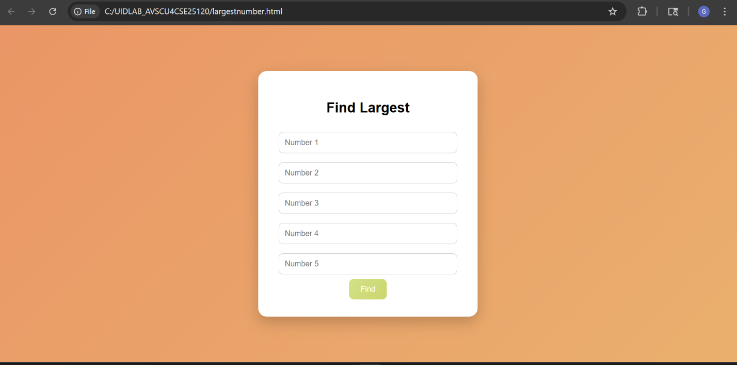

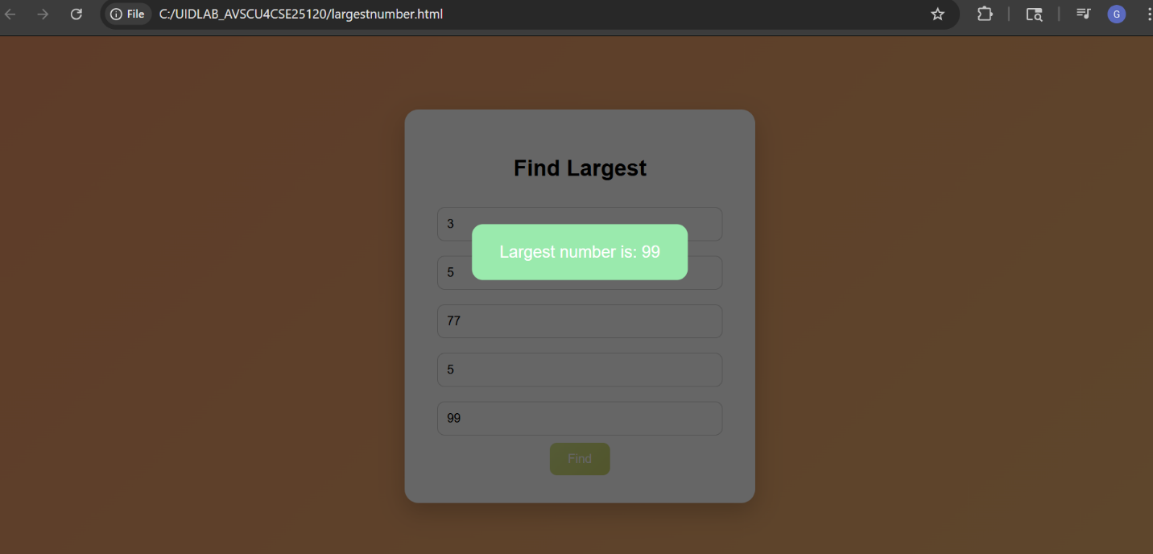

Explanation:
- Function + Event
This defines a function
It runs when button is clicked:
- Variable to Store Result
Stores the largest number
- Main Logic
First Condition
if (a >= b && a >= c && a >= d && a >= e)
• a is greater than or equal to all → largest
Second Condition
else if (b >= a && b >= c && b >= d && b >= e)
b is largest
Similarly:
c → compared with all
d → compared with all
Final Case
else {
largest = e;
}
If none of the above → e is largest
- Selecting Alert Elements
Used for custom popup display
- Displaying Result
Shows result dynamically
6.Showing Popup
Makes alert visible
- Auto Hide
After 2.5 sec → hides popup

10(D).Aim: Write a Javascript for loop that will iterate from 0 to 15.For each iteration, it will check if the current number is odd or even and display a message to the screen.
Procedure:
<!DOCTYPE html>
<html>
<head>
<title>Odd Even Checker (0–15)</title>
<!B.POOJASREE AV.SC.U4CSE25103>
<style>
body {
font-family: Arial, sans-serif;
background: linear-gradient(135deg, #b92c2c, #820818);
height: 100vh;
display: flex;
justify-content: center;
align-items: center;
margin: 0;
}
.box {
background: white;
padding: 30px;
width: 350px;
border-radius: 15px;
box-shadow: 0 10px 25px rgba(0,0,0,0.2);
text-align: center;
}
button {
padding: 10px 20px;
background: linear-gradient(135deg, #dd0e11, #a24b61);
color: white;
border: none;
border-radius: 8px;
cursor: pointer;
margin-bottom: 15px;
}
#output {
text-align: left;
max-height: 250px;
overflow-y: auto;
padding: 10px;
border: 1px solid #ccc;
border-radius: 10px;
}
.even {
color: rgb(15, 0, 128);
}
.odd {
color: rgb(21, 0, 255);
}
</style>
</head>
<body>
<div class="box">
<h2>Odd / Even from 0 to 15</h2>
<button onclick="checkNumbers()">Show Result</button>
<div id="output"></div>
</div>
<script>
function checkNumbers() {
let output = document.getElementById("output");
output.innerHTML = ""; // clear previous result
for (let i = 0; i <= 15; i++) {
if (i % 2 === 0) {
output.innerHTML += "<p class='even'>" + i + " is Even</p>";
} else {
output.innerHTML += "<p class='odd'>" + i + " is Odd</p>";
}
}
}
</script>
</body>
</html>

Output :
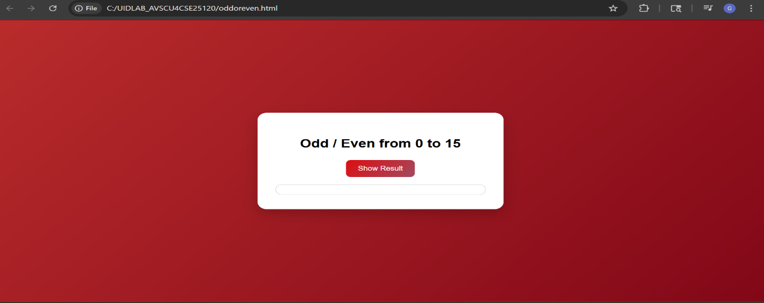
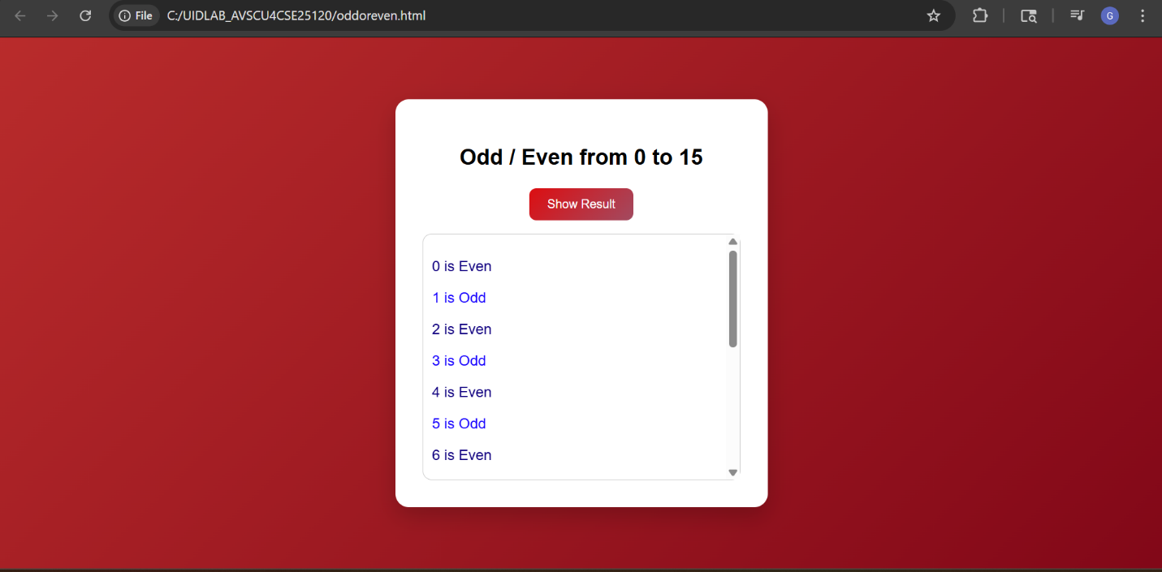

Explanation:
- Function
Defines a function
It runs when button is clicked
- Accessing Output Area (DOM)
document → whole webpage
getElementById() → selects element
- Clearing Previous Data
Removes old results before printing new ones
- For Loop
for (let i = 0; i <= 15; i++)
Breakdown:

• let i = 0 → start from 0
• i <= 15 → run till 15
• i++ → increase by 1
Loop runs 16 times (0 to 15)
Even / Odd Logic
if (i % 2 === 0)
Key concept:
• % → modulus (remainder)
Examples:
4 % 2 = 0 → Even
5 % 2 = 1 → Odd
If remainder = 0 → Even
Else → Odd
5. Displaying Output
10(E).Aim: Write a Javascript program to read 6 subjects marks from the student then compute the average marks of the student.Then this average is used to determine corresponding grade
Procedure:

<!DOCTYPE html>
<html>
<head>
<title>Student Grade Calculator</title>
<!gayathri AV.SC.U4CSE25120>
<style>
body {
font-family: Arial;
background-color: #50c7d2;
text-align: center;
}
.container {
background: rgb(91, 223, 175);
width: 300px;
margin: 50px auto;
padding: 20px;
border-radius: 10px;
box-shadow: 0 0 10px gray;
}
input {
width: 80%;
padding: 8px;
margin: 5px;
}
button {
padding: 10px 15px;
background-color: #34b5e8;
color: white;
border: none;
border-radius: 5px;
cursor: pointer;
}
button:hover {
background-color: #21e0dd;
}
#result {
margin-top: 15px;
font-weight: bold;
}
</style>
</head>
<body>
<div class="container">
<h2>Grade Calculator</h2>
<input type="number" id="m1" placeholder="Subject 1"><br>
<input type="number" id="m2" placeholder="Subject 2"><br>
<input type="number" id="m3" placeholder="Subject 3"><br>
<input type="number" id="m4" placeholder="Subject 4"><br>
<input type="number" id="m5" placeholder="Subject 5"><br>
<input type="number" id="m6" placeholder="Subject 6"><br>
<button onclick="calculateGrade()">Calculate</button>
<div id="result"></div>
</div>
<script>
function calculateGrade() {
// Read values
let m1 = Number(document.getElementById("m1").value);
let m2 = Number(document.getElementById("m2").value);
let m3 = Number(document.getElementById("m3").value);
let m4 = Number(document.getElementById("m4").value);
let m5 = Number(document.getElementById("m5").value);
let m6 = Number(document.getElementById("m6").value);
// Calculate average
let avg = (m1 + m2 + m3 + m4 + m5 + m6) / 6;
let grade;
// Determine grade
if (avg >= 90) {
grade = "A+";
} else if (avg >= 75) {
grade = "A";
} else if (avg >= 60) {
grade = "B";
} else if (avg >= 50) {
grade = "C";
} else {
grade = "Fail";
}
// Display result
document.getElementById("result").innerHTML =
"Average Marks: " + avg.toFixed(2) + "<br>Grade: " + grade;
}
</script>
</body>
</html>

Output :
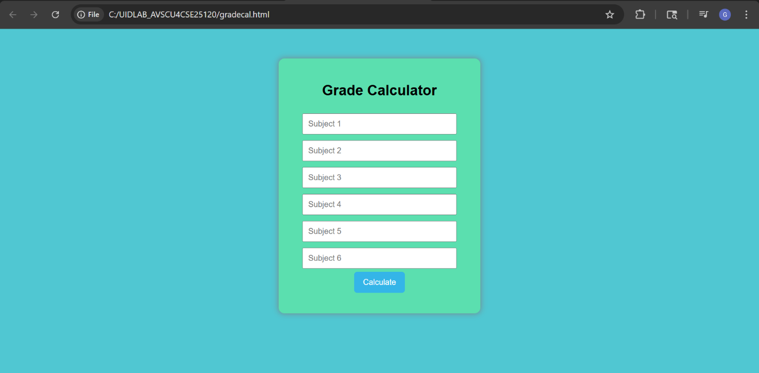
Explanation:
- FunctionA function is a block of code that runs when called.
• It is called using:
- Getting Input Values
Step-by-step:
• document → represents whole webpage
• getElementById("m1") → selects input box
• .value → gets entered value
• Number() → converts string → number
3. Calculating Average
• Adds all marks
• Divides by 6
• Stores result in avg
- Declaring Grade Variable
• Variable to store final grade
- If-Else Condition Used for decision making
• Checks conditions one by one
• Assigns grade accordingly

- Display Output Breakdown:
• innerHTML → displays content inside HTML element
• toFixed(2) → shows 2 decimal places
• → line break

Week-11
11(a).aim: A website requires users to enter a username. The system should display a message while typing if the username is less than 5 characters.
Procedure :
<!DOCTYPE html>
<html>
<head>
<title>Username Validation</title>
<!k.gayathri AV.SC.U4CSE25120>
<style>
body {
font-family: 'Poppins', sans-serif;
background: linear-gradient(135deg, #252b46, #483858);
height: 100vh;
display: flex;
justify-content: center;
align-items: center;
}
.box {
background: white;
padding: 40px;
width: 320px;
border-radius: 15px;
box-shadow: 0 10px 25px rgba(0,0,0,0.2);
text-align: center;
transition: 0.3s;
}
.box:hover {
transform: scale(1.03);
}
h2 {
margin-bottom: 20px;
color: #333;
}
input {
width: 100%;
padding: 12px;
border-radius: 8px;
border: 1px solid #ccc;
outline: none;
transition: 0.3s;
}
input:focus {
border-color: #2e3551;
box-shadow: 0 0 8px rgba(78, 88, 133, 0.5);
}
.message {
margin-top: 12px;
font-size: 14px;
font-weight: bold;
}
.error {
color: #e74c3c;
}
.valid {
color: #2ecc71;
}
</style>
</head>
<body>
<div class="box">
<h2>Create Username</h2>
<input type="text" id="username" placeholder="Enter username"
onkeyup="checkUsername()">
<div id="msg" class="message"></div>
</div>
<script>
function checkUsername() {
let user = document.getElementById("username").value;
let msg = document.getElementById("msg");
if (user.length < 5) {
msg.innerHTML = " Minimum 5 characters required";
msg.className = "message error";
} else {
msg.innerHTML = "Looks good!";
msg.className = "message valid";
}
}
</script>
</body>
</html>
Output:
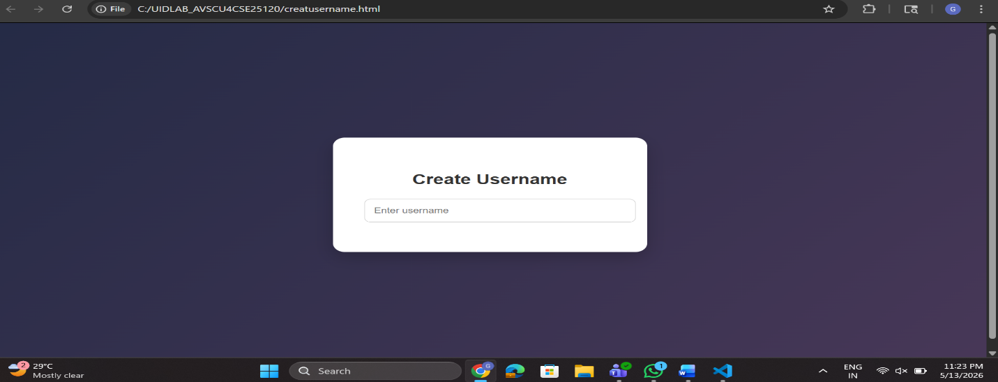

Explanation:
Message styles
.error → red text
.valid → green text
Message display
Empty initially
JavaScript will update this
꾆 4. JavaScript (Logic)
function checkUsername() {
• Function that runs whenever user types
Get input value
let user = document.getElementById("username").value;
• Gets what user typed
• .value → actual text
Get message element
let msg = document.getElementById("msg");
• This is where we show output
Condition check
if (user.length < 5) {
• user.length → number of characters
• If less than 5 → invalid
If invalid
msg.innerHTML = " Minimum 5 characters required";
msg.className = "message error";
• Shows message
• Applies red color (error class)
꾆 5. Flow
When user types:
1. Key pressed → onkeyup triggers
2. checkUsername() runs
3. Gets input value
4. Checks length
5. Updates message + color

11B.
AIM: A registration form should validate email format before submission. If invalid, the form should not be submitted.

PROCEDURE:
<!DOCTYPE html>
<html lang="en">
<head>
<meta charset="UTF-8">
<meta name="viewport" content="width=device-width, initial-scale=1.0">
<title>Registration Form</title>

<style>
body {
font-family: Arial, sans-serif;
background-color: #f2f2f2;
display: flex;
justify-content: center;
align-items: center;
height: 100vh;
}

.form-container {
background: white;
padding: 25px;
border-radius: 10px;
box-shadow: 0px 0px 10px gray;
width: 320px;
}

h2 {
text-align: center;
}

input {
width: 100%;
padding: 10px;
margin-top: 10px;
border: 1px solid #ccc;
border-radius: 5px;
}

button {
width: 100%;
padding: 10px;
margin-top: 15px;
background-color: blue;
color: white;
border: none;
border-radius: 5px;
cursor: pointer;
}

button:hover {
background-color: darkblue;
}

.error {
color: red;
font-size: 14px;
margin-top: 5px;
}
</style>
</head>

<body>

<div class="form-container">
<h2>Registration Form</h2>

<form id="regForm" onsubmit="return validateForm()">

<input type="text" id="name" placeholder="Enter Name" required>

<input type="email" id="email" placeholder="Enter Email" required>

<div id="emailError" class="error"></div>

<button type="submit">Register</button>

</form>
</div>

<script>
function validateForm() {

let email = document.getElementById("email").value;

let emailPattern = /^[^ ]+@[^ ]+\.[a-z]{2,3}$/;

if (!email.match(emailPattern)) {
document.getElementById("emailError").innerHTML =
"Please enter a valid email address";
return false; // Prevent form submission
}

document.getElementById("emailError").innerHTML = "";

alert("Form submitted successfully!");
return true;
}
</script>

</body>
</html>

OUTPUT:
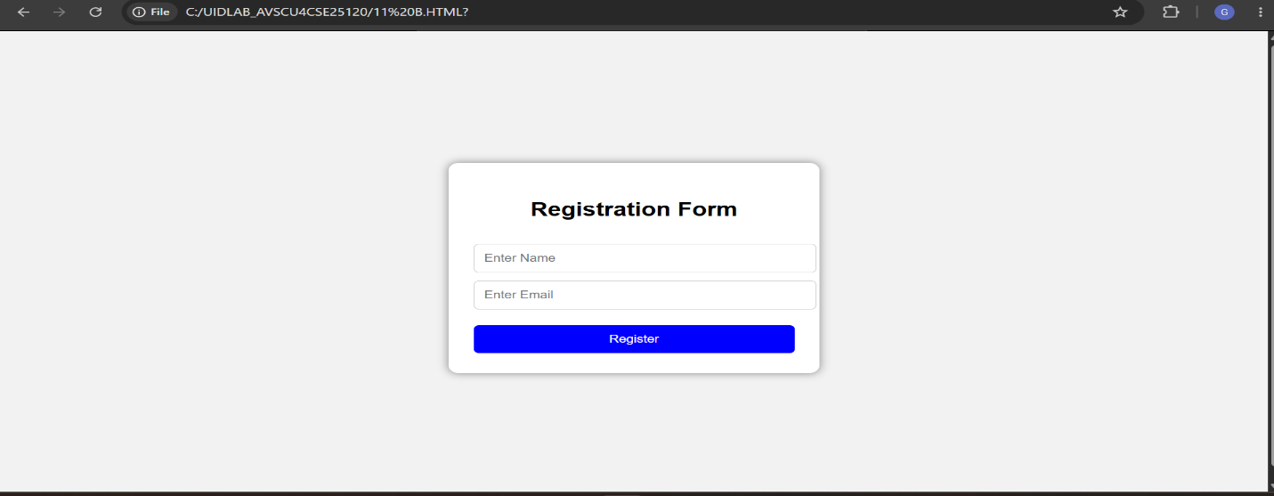

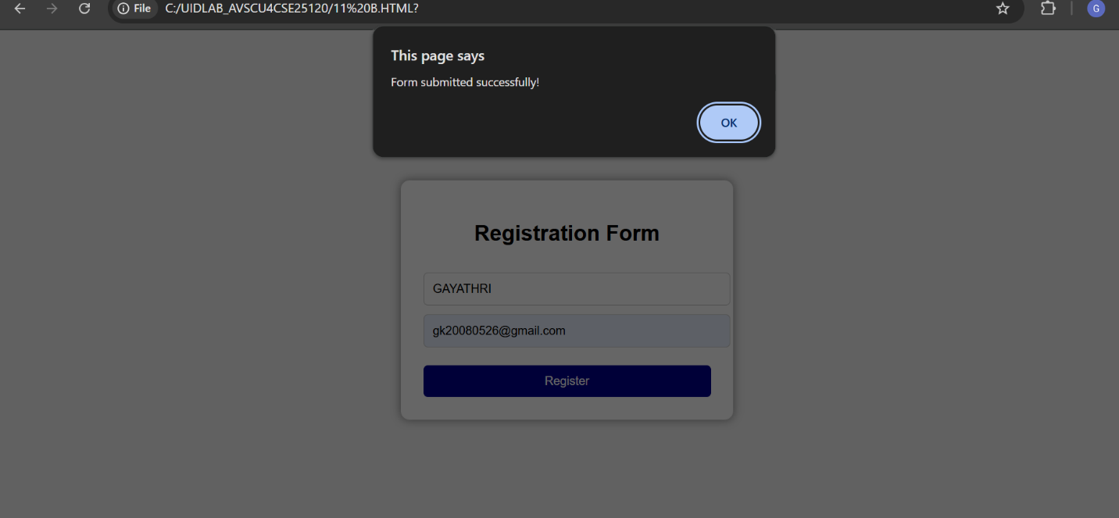

EXPLANATION:

- The program creates a simple Registration Form using HTML, CSS, and JavaScript.
- The HTML part defines the structure of the webpage, including:
  - A heading titled "Registration Form".

  - A Name input field.
  - An Email input field.
  - A Register button.
  - An area to display error messages.
- The CSS part is used to improve the appearance of the form:
  - Centers the form on the page.
  - Adds a white background with rounded corners.
  - Provides spacing and styling for input fields and buttons.
  - Displays error messages in red color.
  - Changes button color when the mouse hovers over it.
- The JavaScript part performs form validation before submission.
- When the user clicks the Register button, the validation function is executed automatically.
- The function reads the email entered by the user.
- A regular expression (pattern) is used to check whether the email format is valid.
- If the email format is incorrect:
  - An error message is displayed below the email field.
  - Form submission is stopped.
- If the email format is correct:
  - Any previous error message is removed.
  - A success message is displayed.
  - The form is allowed to submit.
- The required attribute ensures that both Name and Email fields cannot be left empty.

11.C

Aim: A system should check password strength while typing and display whether it is weak or strong.

PROCEDURE:

<!DOCTYPE html>
<html>
<head>
<title>Password Strength Checker</title>

<style>
body {
font-family: Arial, sans-serif;
background-color: #f2f2f2;
text-align: center;
margin-top: 100px;
}

.box {
background: white;
width: 350px;
margin: auto;
padding: 30px;
border-radius: 10px;
box-shadow: 0px 0px 10px gray;
}

input {
width: 90%;
padding: 10px;
font-size: 16px;
}

#message {
margin-top: 15px;
font-size: 20px;
font-weight: bold;
}

.weak {
color: red;
}

.medium {
color: orange;
}

.strong {
color: green;
}
</style>
</head>

<body>

<div class="box">
<h2>Password Strength Checker</h2>

<input type="password" id="password" placeholder="Enter Password" onkeyup="checkPassword()">

<div id="message"></div>
</div>

<script>
function checkPassword() {
let password = document.getElementById("password").value;
let message = document.getElementById("message");

if (password.length < 6) {
message.innerHTML = "Weak Password";
message.className = "weak";
}
else if (password.match(/[A-Z]/) &&
password.match(/[0-9]/) &&
password.match(/[@#$%^&*!]/)) {

message.innerHTML = "Strong Password";
message.className = "strong";
}
else {
message.innerHTML = "Medium Password";
message.className = "medium";
}
}
</script>

</body>
</html>

OUTPUT:
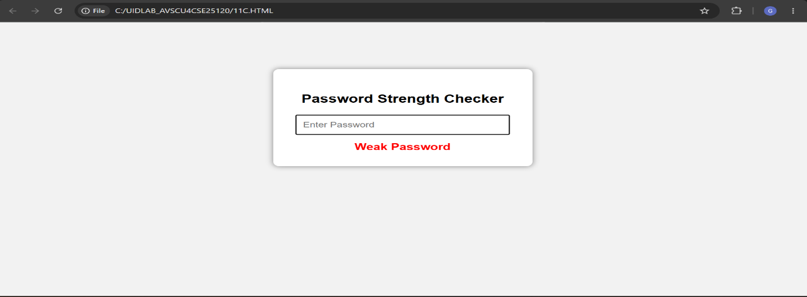

EXPLANATION:
- This program creates a Password Strength Checker using HTML, CSS, and JavaScript.
- The HTML part creates:
  - A heading titled "Password Strength Checker".
  - A password input field where the user enters a password.
  - A message area to display the password strength.
- The CSS part improves the appearance of the webpage:
  - Centers the content on the page.
  - Creates a white box with shadow and rounded corners.
  - Styles the password input field.
  - Defines different colors for password strength messages:
    - Red for Weak Password.
    - Orange for Medium Password.
    - Green for Strong Password.
- The password field uses the onkeyup event.
- Every time the user types or removes a character, the checkPassword() function is automatically called.
- The JavaScript function reads the password entered by the user.
- The program checks the password length first.

- If the password contains less than 6 characters, it is considered a Weak Password.
- If the password has:
  - At least one uppercase letter (A–Z),
  - At least one number (0–9),
  - At least one special character (@, #, $, %, ^, &, *, !),
then it is considered a Strong Password.
- If the password is longer than 6 characters but does not satisfy all the strong password conditions, it is considered a Medium Password.
- The result message is displayed below the password field.
- The color of the message changes automatically according to the password strength:
  - Weak → Red
  - Medium → Orange
  - Strong → Green
Working Flow
- User enters a password.
- The program checks the password instantly while typing.
- If the password is too short → Weak Password.
- If it contains uppercase letters, numbers, and special characters → Strong Password.
- Otherwise → Medium Password.
- The corresponding message is displayed with an appropriate color.

11.D

Aim: A form should validate a mobile number when the user leaves the input field. The number must be exactly 10 digits.

PROCEDURE:

<!DOCTYPE html>
<html>
<head>
<title>Mobile Number Validation</title>

<style>
body {
font-family: Arial, sans-serif;
text-align: center;
margin-top: 100px;
}

input {
padding: 10px;
width: 250px;
font-size: 16px;
}

#message {
margin-top: 10px;
font-size: 18px;
font-weight: bold;
}

.valid {
color: green;
}

.invalid {
color: red;
}
</style>
</head>

<body>

<h2>Mobile Number Validation</h2>

<input type="text" id="mobile" placeholder="Enter 10-digit mobile number"
onblur="validateMobile()">

<div id="message"></div>

<script>
function validateMobile() {

let mobile = document.getElementById("mobile").value;
let message = document.getElementById("message");

// Check exactly 10 digits
let pattern = /^[0-9]{10}$/;

if (pattern.test(mobile)) {
message.innerHTML = "Valid Mobile Number";
message.className = "valid";
} else {
message.innerHTML = "Invalid Mobile Number";
message.className = "invalid";
}
}
</script>

</body>
</html>

OUTPUT:
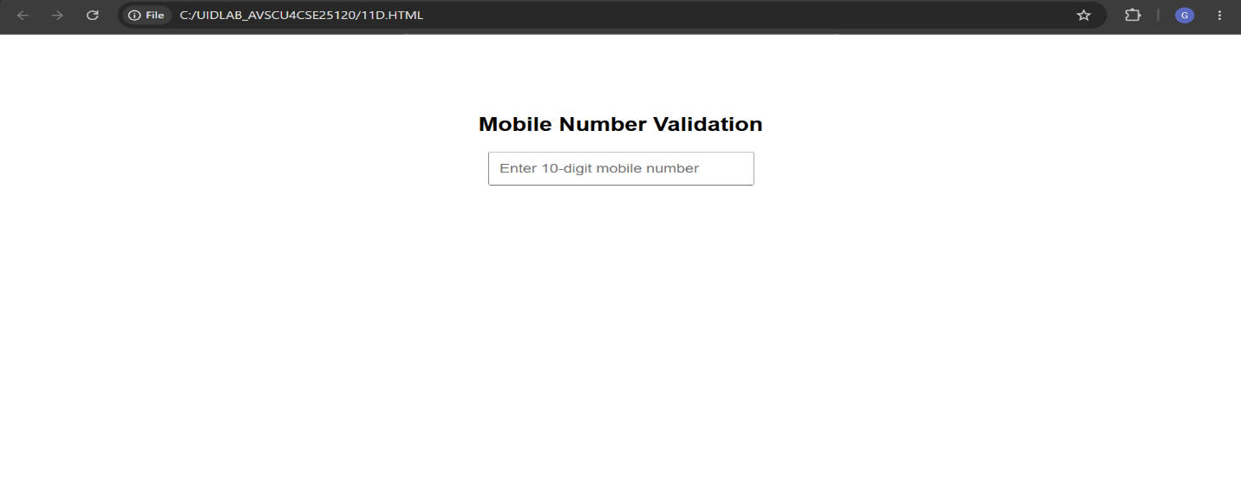

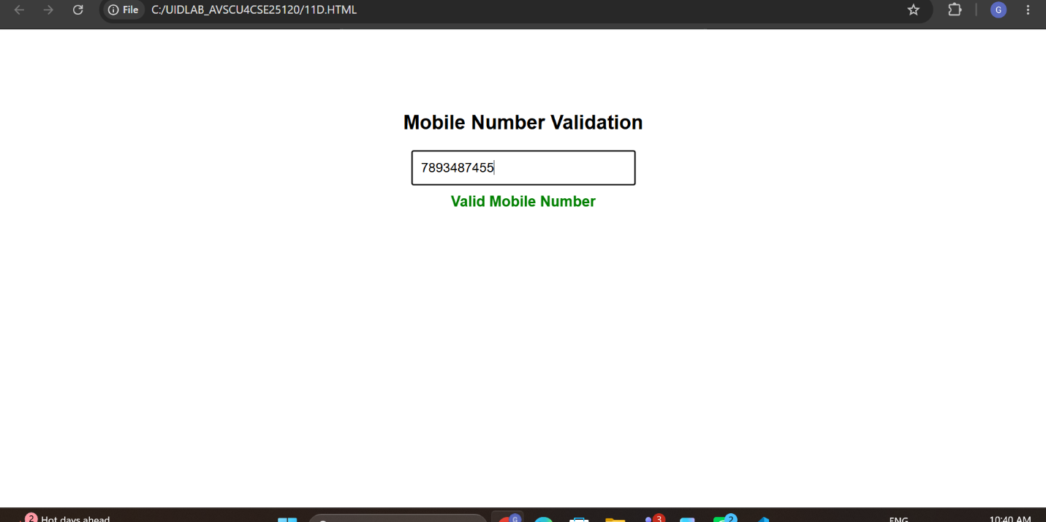

- This program is used to validate a mobile number entered by the user.
- It is developed using HTML, CSS, and JavaScript.
- The HTML part creates:
  - A heading named "Mobile Number Validation".
  - A text input field for entering a mobile number.
  - A message area to display whether the number is valid or invalid.
- The CSS part is used for styling:
  - Centers the content on the webpage.
  - Styles the input field with padding and font size.
  - Displays validation messages in different colors:
    - Green for a valid mobile number.
    - Red for an invalid mobile number.
- The input field uses the onblur event.
- The onblur event is triggered when the user clicks outside the input field after entering a mobile number.
- When the event occurs, the validateMobile() function is executed.
- The function reads the mobile number entered by the user.
- A regular expression pattern is used to verify the mobile number format.
- The validation rule checks that:
  - The number contains exactly 10 digits.
  - Only numeric values (0–9) are allowed.
  - No letters, spaces, or special characters are allowed.
- If the entered number satisfies the pattern:
  - The message "Valid Mobile Number" is displayed.
  - The message color changes to green.
- If the entered number does not satisfy the pattern:
  - The message "Invalid Mobile Number" is displayed.
  - The message color changes to red.
Working Flow
- User enters a mobile number.
- User clicks outside the input field.
- The validation function runs automatically.
- The program checks whether the number contains exactly 10 digits.
- If valid, a green success message is shown.
- If invalid, a red error message is shown.

11E

Aim: Design an HTML page, such that the registration form must validate: Name (not empty) Email (valid format) Password (minimum 6 characters)

PROCEDURE:

<!DOCTYPE html>
<html>
<head>
<title>Registration Form Validation</title>

<style>
body {
font-family: Arial, sans-serif;
text-align: center;
margin-top: 50px;
}

form {
width: 300px;
margin: auto;
padding: 20px;
border: 2px solid #ccc;
border-radius: 10px;
}

input {
width: 90%;
padding: 10px;
margin: 10px 0;
}

button {
padding: 10px 20px;
font-size: 16px;
}

#message {
margin-top: 15px;
font-weight: bold;
}

.valid {
color: green;
}

.invalid {
color: red;
}
</style>
</head>

<body>

<h2>Registration Form</h2>

<form onsubmit="return validateForm()">

<input type="text" id="name" placeholder="Enter Name"><br>

<input type="text" id="email" placeholder="Enter Email"><br>

<input type="password" id="password" placeholder="Enter Password"><br>

<button type="submit">Register</button>

<div id="message"></div>

</form>

<script>

function validateForm() {

let name = document.getElementById("name").value.trim();
let email = document.getElementById("email").value.trim();
let password = document.getElementById("password").value;

let message = document.getElementById("message");

// Email pattern
let emailPattern = /^[^ ]+@[^ ]+\.[a-z]{2,3}$/;

// Name validation
if (name === "") {
message.innerHTML = "Name cannot be empty";
message.className = "invalid";
return false;
}

// Email validation
if (!emailPattern.test(email)) {
message.innerHTML = "Enter a valid email";
message.className = "invalid";
return false;
}

// Password validation
if (password.length < 6) {
message.innerHTML = "Password must contain at least 6 characters";
message.className = "invalid";
return false;
}

// Success message
message.innerHTML = "Registration Successful";
message.className = "valid";

return false;
}

</script>

</body>
</html>

OUTPUT:
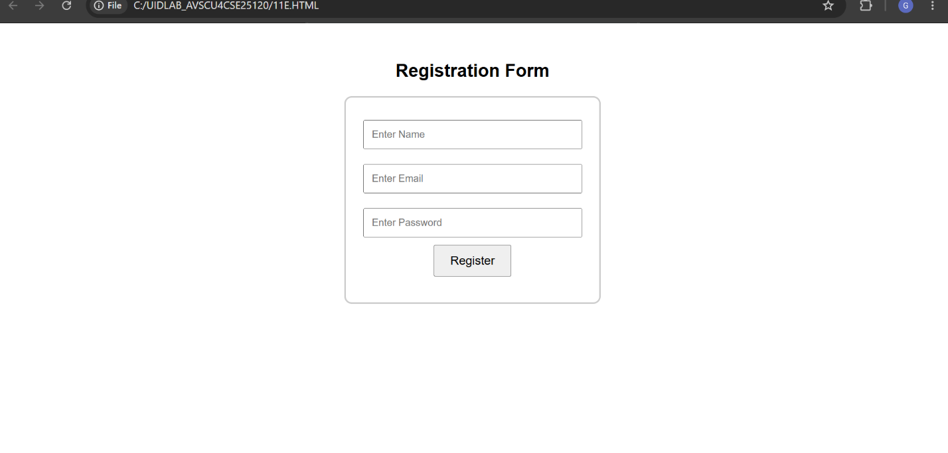

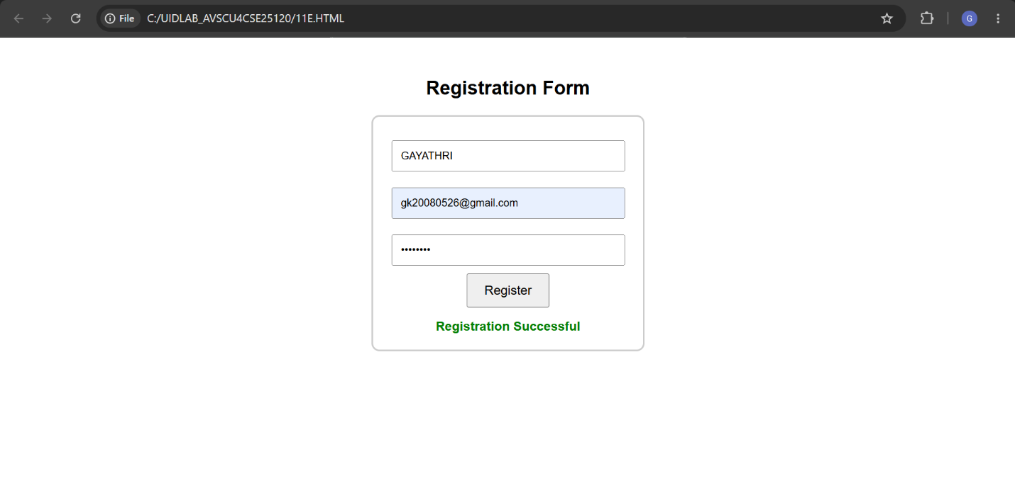

HTML Part
The HTML structure creates the registration form and input fields for user data.
A message section is provided below the button to display error or success messages.
When the user clicks the Register button, the validateForm() function is called automatically.
CSS Part
CSS is used to improve the appearance of the form.
The form is centered on the page and given a border with rounded corners.
Input fields are styled with padding and spacing.
Two CSS classes are defined:
valid → Displays messages in green color.
invalid → Displays messages in red color.
JavaScript Validation
The validateForm() function is responsible for checking all user inputs.
It retrieves the values entered in the Name, Email, and Password fields.
The trim() method removes any extra spaces from the beginning and end of the Name and Email fields.
A regular expression is used to validate the email format.
Name Validation
The program first checks whether the Name field is empty.
If the Name field is empty:
The message "Name cannot be empty" is displayed.
The message color becomes red.
Form submission is stopped.
Email Validation
If the Name is valid, the program checks the Email field.
The email must follow a proper format such as:
user@gmail.com
student@yahoo.in
If the email format is incorrect:
The message "Enter a valid email" is displayed.
The message color becomes red.
Form submission is stopped.
Password Validation
If the email is valid, the program checks the Password field.
The password must contain at least 6 characters.
If the password length is less than 6:
The message "Password must contain at least 6 characters" is displayed.
The message color becomes red.
Form submission is stopped.
Success Validation
If all validations are passed:
The message "Registration Successful" is displayed.
The message color becomes green.
The function then ends after showing the success message.
Working Flow
User enters Name, Email, and Password.
User clicks the Register button.
The program checks whether the Name field is empty.
If valid, it checks the Email format.
If valid, it checks the Password length.
If any validation fails, an error message is shown.
If all validations pass, a success message is displayed.

WEEK-12

1.AIM: : Steps to install NODE Js
PROCEDURE:

STEP-1
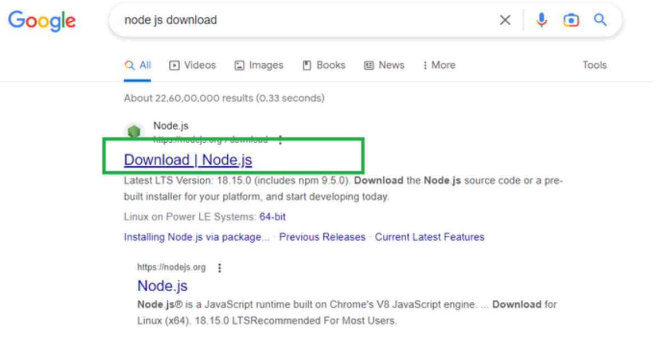

STEP-2
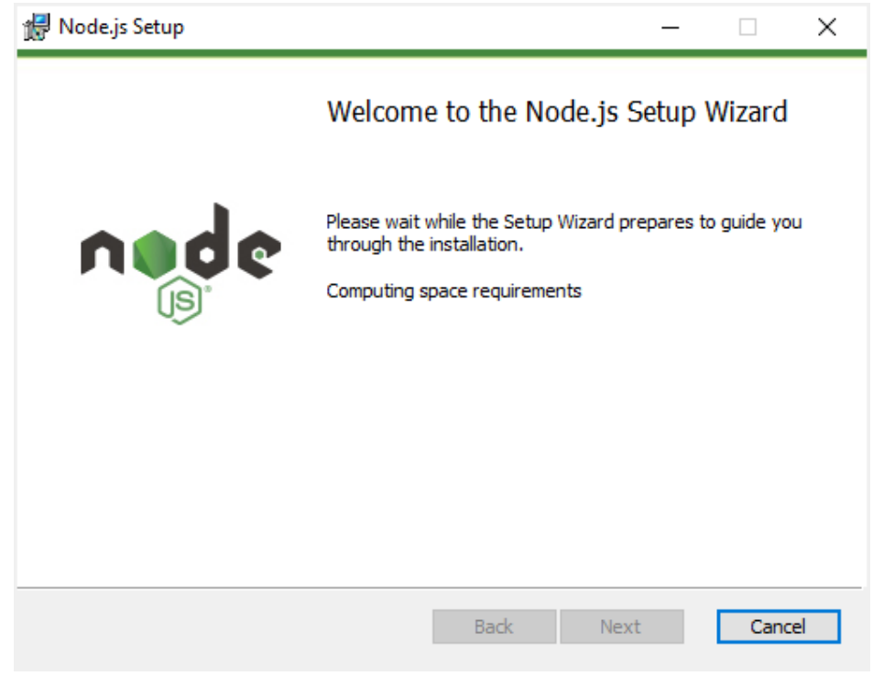STEP-3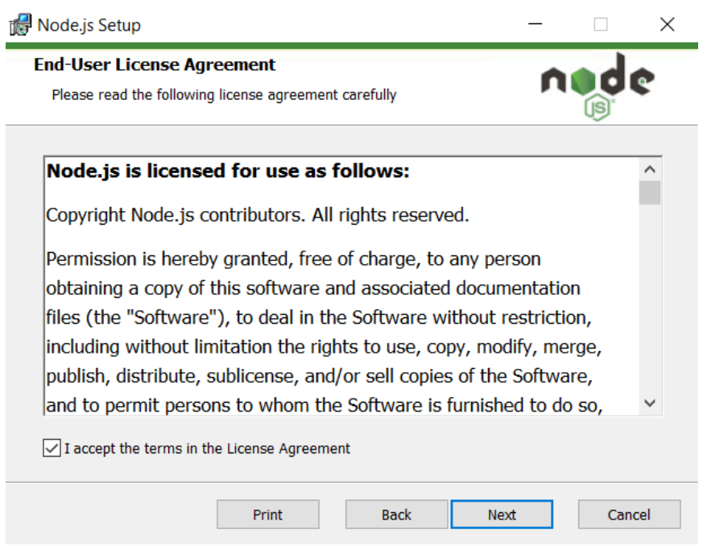
STEP-4
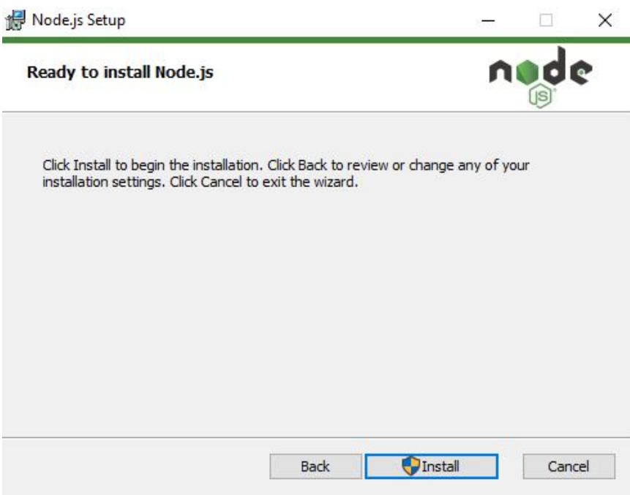
STEP-5

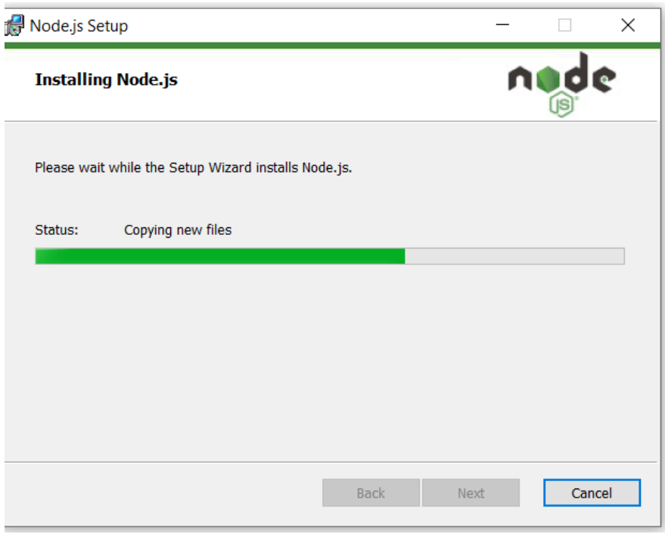
STEP-6